UCLPartners Care Opinion Pilot Programme 2019

Application Form

Guidance on completing this application form

Please read the Information for applicants document before completing this form.
We recommend you save this form to your own computer before completing it. The application should be submitted using the following format: ‘Organisation name’, and ‘applicant’ eg: ‘Merrydown Hospital – Michaela Quinn.docx’ submitted to QI@uclpartners.com.
The deadline for submitting an application is 5pm on 19th April 2019. Late applications will not be considered.
Please note that both the lead applicant and senior sponsor will need to sign the application before submission, so you will either need to use electronic signatures or scan section 3 and 4 of your application.
If your organisation is shortlisted for interview, you will be notified by 5pm on 24th of April. Both the lead applicant and senior sponsor will be required to attend the interview, which will take place on 1st and 3rd of May. While we will do our best to accommodate you at a suitable time, unfortunately, there is no flexibility with these dates.
The sections of this form marked with an asterisk (*) will be used to populate a directory of participants, which will be made public if your organisation is successful for the programme. Please ensure these sections are accurate and don’t forget to let us know if any of these details change.
If you have any questions, please contact QI@uclpartners.com in the first instance.

Section 1: About your team *
Name (and title) of applicant *
Job title *
Professional background *
Department
Organisation *

Key responsibilities *
Please briefly summarise the responsibilities of your current role (100 words max)
Contact address
Please state whether work or home
Contact number *
Mobile preferred
Email address *

Name (and title) of senior sponsor *
Job title *
Professional background *
Department
Organisation (if multi-site please enter site) *

Key responsibilities *
Please briefly summarise the responsibilities of your current role (100 words max)
Contact address
Please state whether work or home
Contact number *
Mobile preferred
Email address *

Section 2: Knowledge and experience of patient feedback
Please answer the following questions demonstrating your knowledge and experience of patient feedback:
1. What current methods are used in your department for gathering patient feedback? (max. 150 words)

2. Describe why you want to pilot Care Opinion in your department. (max. 250 words)

3. How will you maximise this opportunity for your department? (max. 150 words)

Section 3: Senior sponsor support and declaration
To be completed by a member of the department’s senior team e.g. head of department, clinical lead or service manager.
Participating departments are expected to:
- Enable teams to commit fully to the pilot programme
- Ensure teams have opportunities to share their learnings from the pilot
- Work with Care Opinion and UCLPartners across the areas summarised in figure A (Appendix).
Please tell us why you are supporting your department to participate in this pilot programme. (max. 200 words)

Briefly describe how you will actively support your department during the pilot programme. (max. 200 words)

As the senior sponsor, I have read and fully understand the nature of the UCLPartners Care Opinion pilot programme, as well as the support required for the participating department.

I hereby confirm that I have the authority to make the above commitment and undertake to provide internal organisational support during the period of the pilot programme.

I confirm that I have read and fully support this application.

Name of senior sponsor
Signature
Role
Date

Section 4: Declaration of nominated participants
By signing this form, I understand that, if successful:

My personal details will be held in confidence by UCLPartners and in accordance with General Data Protection Regulation (GDPR) and as detailed in the Local Privacy Notice – UCLPartners Care Opinion pilot Programme. The information I have supplied will be used for the purposes of assessing my application and if I am selected, for the purposes of ongoing personnel administration and to support the running of the Care Opinion pilot programme. I consent to UCLPartners sharing my personal data with the team carrying out the evaluation of this programme. If selected, I will participate fully in the programme by, attending events and sharing learning with others and helping inform future cohorts of the programme.

I am aware of the level of commitment required and am confident that I have the full support of my line manager/supporting colleagues and department/organisation for the duration of the initiative.

I will participate in the evaluation of the programme as and when requested by UCLPartners.

If for any reason I am no longer able to participate, I will let UCLPartners know in writing at the earliest opportunity.

I confirm that the information provided in the application form is accurate.

Name – applicant
Signature
Role
Date

Name – senior sponsor
Signature
Role
Date

Voluntary Information
If you are successful, and following completion of the programme, we would like to include your contact details on UCLPartners Database, to send you invitations to relevant workshops and talks, as well as notification of and requests to circulate information on programmes/jobs open for application. This will not affect your application in any way.
If you would like to be included on this database, please tick this box: ☐
Please note that your data will be processed in accordance with this Privacy Notice.

Appendix
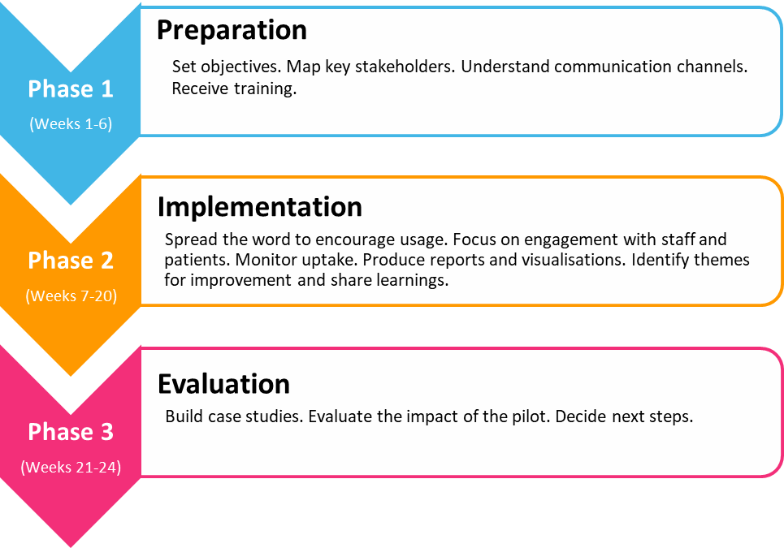

Figure A: UCLPartners Care Opinion 6-month pilot framework

