Implementation Toolkit

for

Clinical Handover

to Pharmacists in the Community

A guide to support implementation of the Transfer of Care Around Medicines model
April 2020

Contents
1 Introduction 3
2 Planning 5
2.1 Establishing a compelling case for change 5
2.2 Enlist influential leaders and champions 7
2.3 Responsibilities of Clinical Handover project team 8
2.4 Determine governance arrangements and develop a project plan 9
2.5 Allocate resources to the project 11
2.6 Assess current barriers and facilitators to change 11
2.7 Identify project stakeholders 12
3 Organisational leadership 14
3.1 Analyse current issues and seek out good practice 14
3.2 Collect baseline data and undertake a risk assessment 14
3.3 Identify other safety and quality initiatives 14
4 Simple solution development 15
4.1 Flow chart your current handover processes against the principles of medicines optimisation 15
4.2 Design an improved handover solution 16
4.3 Develop tools to help implement the solution 16
5 Stakeholder engagement 17
5.1 Develop a stakeholder engagement strategy 17
5.2 Develop marketing tools 17
5.3 Engage change champions 17
6 Implementation 18
6.1 Develop a plan for implementation 18
6.2 Pilot the new solution 20
6.3 Review and revise the solution 20
6.4 Sustain the solution in the pilot site 20
6.5 Spread the project to other clinical settings 20
6.6 Provide ongoing education and training to new and existing employees 21
7 Evaluation and maintenance 21
7.1 Develop an evaluation plan 21
7.2 Analyse and compare baseline and post-implementation data 21
7.3 Disseminate evaluation data and provide feedback to stakeholders on the project 22
8 Acknowledgements 22
9 Resources Appendix 22

Introduction
Welcome to the Implementation Toolkit for Clinical Handover for planning and the implementation of clinical handover services from hospital to pharmacists in the community.
An Implementation Toolkit is an assembly of instruments that, when used collectively or separately, can be useful for implementing a new program, practice, project, or initiative. Users can apply the toolkit in its entirety, or they may find certain portions of it particularly informative for their needs.
Toolkits are designed to help users implement more seamlessly, thereby bridging or reducing the gap between implementation and practice. They provide a blueprint for what to do, when to do it, and how to do it.
There are many theories and frameworks to better understand service/intervention implementation. Here we have drawn upon the Consolidated Framework for Implementation Research (CFIR) (Fig. 1) to inform the development of the Toolkit to guide and optimise the implementation of clinical handover service design, delivery and evaluation. The following sections aim to capture each of the factors of the CFIR. We have attempted to draw upon experiences of implementing these services nationally.

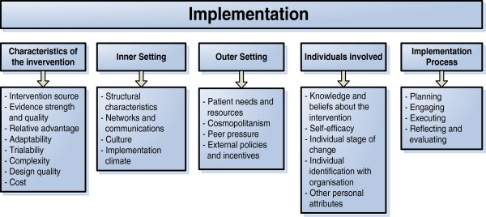
Figure 1. The constructs of the Consolidated Framework for Implementation Research
This Toolkit is a how to guide for commissioners, managers and providers reviewing and implementing local clinical handover processes. The Toolkit refers to and draws upon previous documentation (e.g. various Royal Pharmaceutical Society (RPS) reports and National Institute for Clinical Excellence (NICE) guidance) and adds further guidance on the implementation process. The Toolkit has been designed to be used in pharmacy settings in primary and secondary care.
Clinical handover is more than just a transfer of information. Clinical handover is defined as:
“The transfer of professional responsibility and accountability for some or all aspects of care for a patient, a group of patients, to another person or professional group on a temporary or permanent basis.”²

Planning

Establishing a compelling case for change
The case for clinical handover articulated below has been adapted from a previous document authored by the Academic Health Service Networks (AHSNs) of Wessex and North East and North Cumbria (NENC) and endorsed by the RPS.
Many patients leave hospital having had new medicines initiated, doses of existing medicines changed, and medicines stopped. Unintended discrepancies in patients’ medicines after discharge from hospital frequently occur, affecting up to 87% of patients. Patients’ understanding of the nature of and reasons for changes made to their medicines in hospital is often incomplete; hence, it is unsurprising that their medicines-taking may be different from that intended by the hospital. Furthermore, during an admission, problems with a patient’s medicines may be identified, which are more appropriately managed by the primary care team, including the community pharmacist.
Medicines-related problems after hospital discharge are associated with potential and actual adverse health consequences, many of which are preventable. The literature shows clear potential to reduce medicines-related problems after discharge and thus a role for Discharge Medicines Use Reviews (DMURs). There is some evidence from other countries (notably the Netherlands, Australia and Wales) that post-discharge medicines reviews are effective in resolving discrepancies and problems in medicines use. The DMUR has been part of the community pharmacy contract in England since 2011. It covers patients recently discharged from hospital who had changes made to their medicines while they were in hospital. Ideally, patients discharged from hospital will receive an MUR within four weeks of discharge but in certain circumstances, the MUR can take place within eight weeks of discharge.
Guidance was published in January 2012 showing how the New Medicine Service (NMS) and DMURs can be used to provide a seamless care pathway for patients who transfer from hospital to the community setting. It was developed and published by NHS Employers and the Pharmaceutical Services Negotiating Committee (PSNC), working with a hospital and community pharmacy reference group and endorsed by the RPS. In order to increase the uptake of DMURs, several areas of the country have developed Clinical Handover schemes to help hospitals directly refer patients to their community pharmacist in order to receive support around their medicines on discharge from hospital.
A recent systematic review assessing transfer of care initiatives internationally, reported that interventions that include community pharmacists achieve statistically significant reduction in drug related problems. Studies that document evidence of UK-based services aiming to improve clinical handover and reduce readmissions show that:
- Community pharmacy follow up care is associated with lower numbers of readmissions and shorter hospital stays (Nazar et al.)
- Integrated medicines management services to improve clinical handover are associated with lower rates of preventable medicines-related readmissions. (Barnett at al.)
- Discharge MURs offer the opportunity for medicines reconciliation and patient education and medication counselling (Ramsbottom et al.)
For a clinical handover initiative to be successful, staff need to understand the rationale for the service and hence the need for their practice to change. This process involves gathering information about local experience to construct a compelling case for change. Information that supports the case for change should be tailored so it is of direct relevance and demonstrates benefits to different target groups. The RPS innovators toolkit: Hospital referral to community pharmacy documents the benefits of referrals for individuals and are summarised in Box 1.
Patients:
- Receive support with their medicines through formal contact with their community pharmacist
- Reduced or no hospital admissions or emergency department attendances
- Reduced risk of re-admission as a result of medicines errors
GPs:
- Knowledge that the patient has engaged with a medicine optimisation consultation provides assurance that they are taking their medicines correctly and minimising waste
- Having an accurate list of medicines can be important for disease/medicine combinations as part of the Quality Outcomes Framework (QOF) indicators
Community pharmacists:
- Facilitates better working relationships with hospitals and GPs
- Facilitates better professional relationships with patients
Hospital pharmacist/technician
- Facilitating patient-centred seamless care
- Builds stronger ties with community colleagues and reduces hospital admissions
Chief pharmacist
- Improvements in medicines optimisation leads to more efficient medicine usage and less waste
- Clinical team are integrated into a wider patient pathway

Finance director:
- Reduced readmissions mean less bed pressures and fewer unnecessary admissions for which hospitals may not receive a full tariff payment
- Supports financial sustainability once the practice is embedded.
CCG Medicines management/optimisation team
- Better use of medicines so less waste
- Better integration of patient pathways across sectors of care
- Potential to spread innovative practice to non-acute providers such as community services
- If domiciliary services are in place more referrals can be made

Box 1. Some benefits of effective clinical handover services for groups of stakeholders.⁸

Enlist influential leaders and champions
This Toolkit is primarily designed for those working to implement or optimise a clinical handover initiative. However, an executive leadership can provide vision, structure and support mechanisms.
The RPS innovator’s toolkit: Hospital referral to community pharmacy,⁸ recommends that the group should initially include a hospital lead, the chair of Local Professional Network (LPN), a lead from the Local Pharmaceutical Committee (LPC), a Clinical Commissioning Group (CCG) medicines management/optimisation lead and patient representatives. The local AHSN will be able to facilitate spread and implementation across the area.
These stakeholders should all have a role and responsibility in the design and delivery of high quality patient care. Linking the clinical handover with the stakeholders’ other key performance indicators, goals and initiatives will facilitate its successful implementation and adoption.
Stakeholder | Role and responsibility
Local Pharmaceutical Committee (LPC) | Provide the vital link to all Community pharmacy contractors in the area and provide essential support for the roll out and sustainability of the project.
Local Professional Network (LPN) | Provide the links to NHS England locally and can help to ensure pharmacy contractors are aware of the project and their responsibilities.
CCGs | Can ensure that levers are in place to embed the referral pathway. They may put it in the local commissioning intensions or endorse Trust QIPP plans out help ensure the local STP/ ICS is aware of the benefits
Sustainability and Transformation Partnerships (STPs)/ Integrated Care Systems (ICS) | Responsible for ensuring effective transformation of services and “reducing avoidable readmissions” is a key element of what they are addressing. They can help ensure Trust engagement.
AHSN | UCLPartners can support with advice and guidance as well as accessing some resources used by Trusts across the national AHSN Network to deliver TCAM.

Box 2. Potential key stakeholders and some of their roles and responsibilities.

Responsibilities of Clinical Handover project team
Successful implementation of a handover initiative requires a team approach. The collaborative working will facilitate change. The dynamics of the team may differ according to local political context, drivers and challenges.
Newcastle-upon-Tyne NHS hospitals (NuTH) began working on Transfer of care as an early implementer of electronic discharge summaries in 2010. By 2012, the Director of Pharmacy had identified the need for a community pharmacy partner with which to innovate a transfer of care service. Consequently, discussions began with the North of Tyne LPC to explore potential solutions. NuTH worked with North of Tyne LPC and the managers of PharmOutcomes®*, to develop the Transfer of Care service that comprises of an electronic referral of a patient’s medicines-related information from hospital to community pharmacy staff. This initiative was launched in July 2014, the first in the UK and was the first involving PharmOutcomes®. It was recognised that the NENC AHSN would be able to facilitate broader adoption; so an AHSN project team was established to monitor the early implementation and delivery of this service, and included representatives from NuTH and from surrounding Trusts, regional LPCs and LPNs, academia, and patient groups. These members also adopted the role of a champion in their respective areas, enabling and pushing forward the roll out, overcoming barriers and supporting staff teams. The champions were agents of change and dedicated time with regular meetings and communications to deal with logistical and co-ordination issues.
* PharmOutcomes® is a secure web-based clinical service platform used by the majority of the community pharmacies across the country used to record and collate pharmaceutical service data within community pharmacies

Box 3. The project team at Newcastle-upon-Tyne Hospitals clinical handover service.
The responsibilities of the project team could include:
- Identifying, consulting and engaging with key stakeholders
- Assessing barriers and enablers for implementation and adoption
- Assessing current practice to identify priority areas and strategies for implementation
- Working and engaging with executive leadership groups to facilitate implementation
- Providing guidance, direction and support to the staff and teams at the point of care
- Negotiating appropriate allocation of resources (time, staff, development and finance)
- Implementation – including piloting and spread
- Evaluating process and outcome measures on an ongoing basis
- Report issues in implementation to executive leaders
- Working with executive leaders to sustain and spread improvements

Determine governance arrangements and develop a project plan
The established project team will need to determine and agree the governance arrangements, which include the reporting and accountability framework for the project and defining team member’s roles and lines of communication.
An over-arching project plan will guide the project team and should include:
- Specific changes or outcomes from the project
- Identified groups of people who will need to adopt new practice
- Specific groups of patients who will be targeted for the handover initiative (or not)
- Specified process that needs to be adopted
- Identified measures that will be used to monitor progress
- An initial target that is likely to be achievable within the resources available
- Develop a project timeline for goal achievement

A project plan for the implementation process could include the steps outlined in Box 4. The management, organisation and delivery of these falls to the various stakeholders represented within and out with the project group suggested in section 2.2.
Project step | Comments
Determine and confirm the method of implementing | There are three methods of implementing information transfer to facilitate the clinical handover:  - Full electronic integration  - Partial electronic integration  - Manual data entry via web portal. Early implementer experience evidences this option as least preferred due to the additional data entry requirement and poor stream-lining of process.  In each case, early engagement of Trust IT vital to inform and plan implementation.
Determine the patient groups to be included | Currently Trusts are adopting a varied approach. For example, some are employing the PREVENT checklist, and others referring from specific wards. Recent consensus work undertaken nationally indicates that the top referral criteria should include: high risk drugs, recently changed medication and new medication on discharge. Refer to section 4.3 for more detail.
Determine the information to be provided to patients | Examples of leaflets used by Trusts across UCLPartners geography can be found on the UCLP TCAM webpage. The Wessex AHSN Mo video has proven successful across numerous sites as an effective format to inform patients of the potential care that can be provided through clinical handover initiatives – also linked on the UCLPartners TCAM webpage.
Determine the information that the Trust would like to send to the community pharmacy | The RPS recommends core content of records for medicines when patients transfer between care providers, which can inform information that is shared.
Determine the IT requirements and agree a timescale for implementation and sign off | The RPS innovators toolkit: Hospital referral to community pharmacy [PART 2: MAKING IT HAPPEN describes some basic requirements of an e-referral system. PharmOutcomes® (Pinnacle) and Refer-to-Pharmacy (Webstar) are two systems that offer full electronic integration. Feedback from established implementers recommend engagement with platform designers is crucial to ensure the interface and delivery is fit for purpose and appropriate for data capture and recording.
Determine the information governance requirements and agree a timescale for clarification and sign-off | There are information governance requirements around the sharing of information and consent which need to be considered locally and specific to the IT solution adopted. A Privacy Impact Assessment may be needed. Early engagement with Trust Information Governance lead is required to work through potential barriers and challenges.
Develop a standard operating procedure (SOP) and the behaviour changes required | Local requirements, existing processes and local information governance and consent practice will be incorporated into the developed SOP. An example SOP for community pharmacists is available at https://psnc.org.uk/331753-tcam-sop-template/
Develop and test message transport processes | To test feasibility and usability. Check for the potential for a ‘push’ message to community pharmacy to increase completion of the handover and engagement with the patient in primary care. If using Pharmoutcomes, the System supplier Pinnacle will assist with this and have test systems to use.
Review AHSN research proposals and gain sign off locally | There should be an aim to evaluate the benefits of transferring data to community pharmacy as part of the clinical handover.
Train staff | Develop and deliver appropriate training.
Communicate with and train community pharmacists | Develop and deliver appropriate communication and training. The RPS innovator’s toolkit: Hospital referral to community pharmacy⁸ includes some aspects of a communication and dissemination plan.

⁶

Allocate resources to the project
The project plan will explore the potential resources required to ensure implementation is possible. Planning at the outset will ensure feasibility and sustainability are considered.
Resources can be categorised as human, fiscal and physical requirements and are interconnected. Time will be one of the most significant resources required, and if inappropriate fiscal and physical resource is invested in implementation, then the time for implementation will be longer. It is recommended that at least 12 months be allocated to the implementation of a new initiative. This means that enough project management, monitoring and capacity for optimisation are factored into the implementation and delivery over the initial 12 months.
The RPS innovator’s toolkit: Hospital referral to community pharmacy,⁸ discuss some of the potential costs involved in the adoption of referral systems, which include:
- Costs to deliver NMS and MURs
- Hospital staff resources
- Community staff resources
- Systems and solutions costs

Assess current barriers and facilitators to change
The context within which a new initiative is implemented will have a significant impact on the assimilation of innovation. Considering and assessing the context and environment is important to consider in strategizing implementation and setting achievable goals. Key components include strong leadership, clear vision, good management relations and effective data capture and reporting systems.
In the assessment of current issues, barriers to implementation can be uncovered. These can exist at several levels – the initiative itself, the individual (negative belief about change), the organisation (lack of resource), and the broader environment (lack of a sustainable funding mechanism). Understanding these will inform and frame the strategies utilised within implementation.
Some common organisational and project characteristics that enable successful implementation of handover include:
- Tailoring a tool or process for the specific initiative environment, which is practical and an improvement on current practice
- An organisational environment that is supportive and favourable to change. The case of change is compelling and is made an organisational priority to embed into routine practices and structures
- Influential people driving change. A dedicated project manager is a key factor for success
- Demonstrable and positive outcomes resulting from change that are easy to collect and report, e.g. adverse events data showing reduction in patient harm, staff perceptions of improved communication, role clarity and confidence levels.

A SWOT (Strengths, Weaknesses, Opportunities and Threats) analysis is a simple way to assess the barriers and facilitators to change. This will identify potential risks and issues that affect implementation and strategies to mitigate these risks prior to implementation and ultimately be useful to inform the implementation plan.
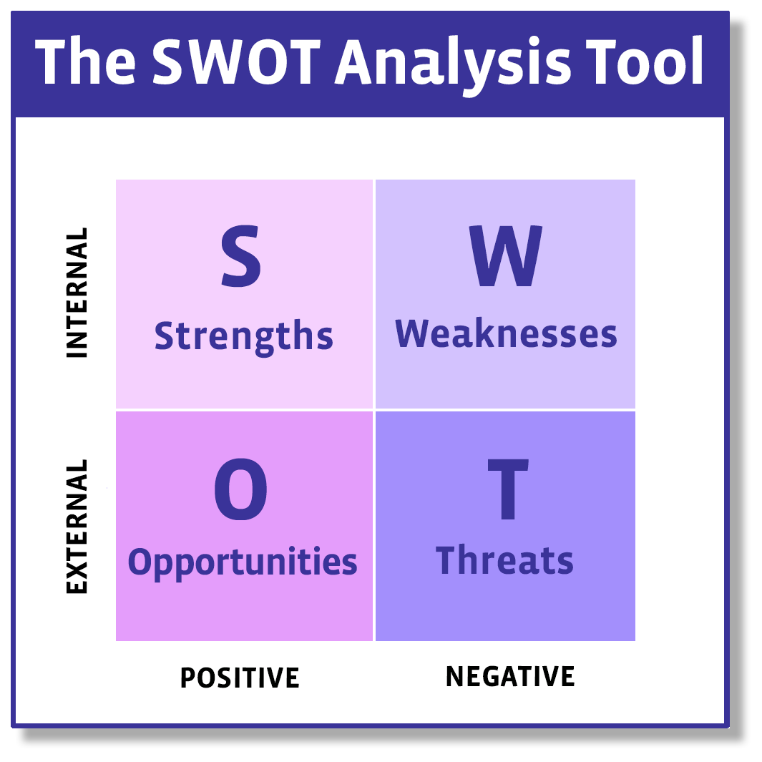

Identify project stakeholders
Stakeholder engagement at all levels of the organisation is essential for leading change. The established project team will need to identify key internal and external stakeholders that may assist or impede implementation. These should be identified and included in the early stages to ensure effective change management processes.
As an example, the nature of the clinical handover process provided for the TCAM pilot at Newcastle upon Tyne NHS Hospital Trust was complex and is depicted in Fig 2.
The mapped patient journey highlights the multistep process and the various stakeholders involved in the system. To ensure each step of the journey is best managed, representation of stakeholders responsible and/or involved for each step should exist within the project team. The project team established regular meetings with representatives from the providers (hospital pharmacy, community pharmacy), LPN, LPC, patient groups, AHSN and academia, where the remit included aspects listed in 2.3 Form a project team. This experience highlighted the key role of the LPC to ensure widespread, continuing engagement with the pharmacists in community.
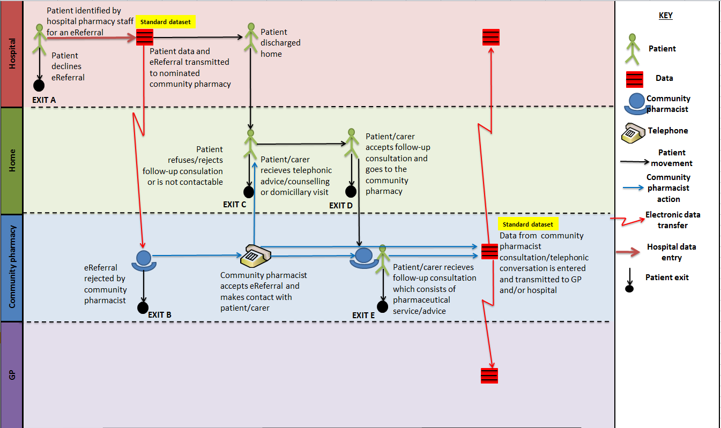
Figure 2. The potential journey of a patient if offered an electronic (eReferral) during their hospital admission to their community pharmacist for follow-up care.

Organisational leadership
The organisational leadership phase commences as soon as the project team is established, and resources are identified.

Analyse current issues and seek out good practice
The project team should determine current practice to validate the need for change. This could be assessed from incident or adverse event reporting or mapping the patient journey to identify gaps in patient care and safety. Similarly, if there are current practices within the organisation, or evidence of good practice being reported elsewhere, this should be sought out, celebrated and adopted or spread this within the organisation. Engaging with the local AHSN will facilitate learning of how services are implemented and managed elsewhere and the respective impact. Documentation such as the RPS reports and innovator’s toolkit include case studies that again describe clinical handover services, and published literature from national and international initiatives, can offer further valuable insight. Documents such as this toolkit and resultant discussions in national and local forums, offer specific information and guidance but also provide an opportunity to engage in debate and critique for further optimisation and improvement.

Collect baseline data and undertake a risk assessment
The collection of local baseline information will support the case for change to improve clinical handover. Useful information could include specific cases where patients transitioning between healthcare settings experienced harm and data demonstrating the contribution of poor handover to adverse events or inefficiencies. The project team should ensure that baseline data is captured and that the initiative is designed in such a way to enable monitoring of performance and impact to compare to the baseline data. This also indicates an area where more work is required to substantiate the true significance of clinical handover on patient care.
Undertaking a risk assessment on the data obtained will assist the team to determine current problems with handover and potential risks of current practice for patient safety.

Identify other safety and quality initiatives
The clinical handover can be integrated with existing processes and structures that aim to improve safety and quality. This can strengthen the clinical handover and facilitate adoption and normalisation.
For example, with the introduction of new hospital IT systems, explore the potential to support clinical handover via electronic referral to community pharmacy, and identify the capacity to transmit appropriate information and capture useful data for the service.

Simple solution development
Clinical handover services within a site should be standardised, with a clearly structured process and defined transfer of relevant patient information, ascribed accountability and responsibility.
The clinical handover service is ultimately a vehicle to deliver medicines optimisation. The RPS good practice guidance: Medicines Optimisation, describes four principles consistent with existing national guidance and good practice guidance that supports medicines optimisation.
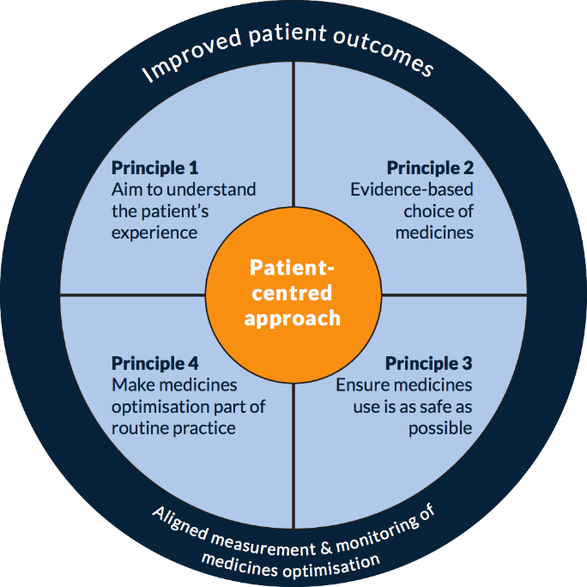
Figure 3. Summary of the four principles of medicines optimisation.¹¹
The short excerpts provided by pharmacist practitioners aiming to demonstrate these four concepts, all relate to patients having transitioned between care settings and experiencing medicines and/or disease-related issues that the practitioner was able to intervene and address.
Consequently, these four principles can act as a framework in the design of a clinical handover service. The good practice guidance also includes anticipated outcomes if these principles underpin clinical practice, which can inform the types of outcomes that can be measured from clinical handover services.

Flow chart your current handover processes against the principles of medicines optimisation
Develop a mapped patient journey as they travel through the clinical care settings based on current practice. Compare the mapped process with the principles of medicines optimisation that will allow you to identify which areas of patient care are currently performed well, any existing gaps in the process and areas where improvements can be realised. The lean thinking approach can be adopted to ensure the newly design patient pathway is resource efficient to improve patient care and experience.

Design an improved handover solution
The most effective clinical handover solutions are practical and simple improvements, which ease existing time pressures, reduce stress to staff and are supported by senior management.
The mapped patient journey can inform the design of components of an improved or new clinical handover solution. The solution should be:
- ‘fit for purpose’, i.e. appropriate for staff to perform in the role in an efficient and effective way, and does not involve unnecessary people, steps or requirements;
- An efficient use of resources and staff time, which may inform the chosen form of integration, i.e. partial, full or manual;
- Beneficial to the organisation in terms of improved care processes for staff and for the care provided to patients.
A recent report commissioned by Wessex AHSN and Rowlands pharmacy, documented that an early version of a pharmacist-led domiciliary review post-discharge service had components of the process that were inefficient and ineffective. For example, hospital pharmacy staff had specific referral criteria to adhere to when considering inpatients for the service, and staff were then required to initiate the referral by communicating with a designated member of staff. These steps of the process were reported to impede staff ability and confidence to recruit patients into the service. Subsequent changes were made to the service to improve effectiveness and efficiency, such as simplifying threshold criteria to recruit patients and streamlining the referral itself.

Develop tools to help implement the solution
There is an increasing number of reports, documents and communication materials that can spread good practice, reduce inefficiency and duplication in design and delivery and contribute to the evidence base for clinical handover.
Recently commissioned work in the North East aimed to identify appropriate inpatient referral criteria to trigger clinical handover. Preliminary findings found that practitioners valued the role of ‘professional judgement’ to prompt clinical handover. This resonates with the literature from international studies, however there is a counterargument to suggest that this alone would lead to unstandardized care provision. Further work could explore the meaning of ‘professional judgement’ among staff triggering clinical handover to investigate the appropriateness for practice and potential alignment to other reported criteria. Further consensus work was undertaken with stakeholders nationally which established three key referral criteria including patients on high risk drugs, or one who had experienced changed medication whilst in hospital or one who was receiving a new medication on discharge⁹.
The PharmOutcomes® support pack and resources available on the PSNC, and East Lancashire Hospital Trust (ELHT) Refer-to-pharmacy (https://www.elht.nhs.uk/services/refer/useful-videos) websites offer exemplar resources to aid in the implementation of a clinical handover service.

Stakeholder engagement
All relevant people identified to provide advisory, facilitative roles at the beginning of the project can improve the adoption of clinical handover and ensure the best use of resources.

Develop a stakeholder engagement strategy
Communication strategies need to be tailored to the nature and context of the individual stakeholder to ensure communication is effective. Regular updates and opportunities to discuss the project are important at all phases of the project.
A multi-method communication plan will help keep all informed at a pace and depth appropriate for each group of stakeholders.

Develop marketing tools
Marketing and promotion will generate interest, engagement and participation in the project.
Examples of marketing include:
- Education or online learning guides
- Colourful posters, lanyards, pens and notepads with a handover logo and/or slogan
- Regular updates to staff and management meetings
- Feedback sessions provided to project team and staff on project success
On behalf of all AHSNs, Wessex AHSN have developed a ‘Meet Mo’ campaign with accompanying patient-facing videos (http://wessexahsn.org.uk/projects/171/meet-mo) that encourage patients to engage with community pharmacy when moving back home after a hospital stay and will their medicines usage.
The East Lancashire Hospitals NHS Trust Refer-to-Pharmacy scheme dedicated time and resource to develop patient, staff and stakeholder videos for the purpose of marketing to these groups.
Experience from established implementers report the significance of launch and sharing and feedback events to engage stakeholders from the start and maintain interest and sustainability. UCLPartners can support by providing relevant case studies if required. This is a powerful marketing, motivating and engaging resource that has impact across all stakeholder groups, providers and patients.
Local launch and milestone events also serve to invigorate engagement, investment and delivery.

Engage change champions
Successful projects are driven by a dedicated person, or team of people, with a relentless drive to overcome barriers and achieve change to practice.
Around the country there are recognised project team members who have driven the initiative and sustain engagement. UCLPartners can supporting by linking partner organisations to share experience of launching TCAM processes and sharing learning.

Implementation
All developmental phases until this point are to ensure implementation is as well planned out as it can be before embarking on change.
Successful implementation will require ongoing staff commitment as well as the use of support materials including memory triggers, education materials and information tools. The implementation process should make sure that staff receive positive feedback and successes are celebrated with the project team.

Develop a plan for implementation
In section 2.4 process steps were suggested which also form the basis of an implementation could plan for the early development. Further elements to consider are presented in Table 2.

Table 2. An example implementation plan
Implementation step | Actions | By who | By when | Resources needed | Progress measures
Decide specific implementation processes and strategies | Develop education material, etc.
Develop communication plan  How will information be communicated  When/how often information will be communicated | Set a launch date to raise awareness and increase engagement  Set dissemination, milestone and celebratory events
Risk assessment of action plan  Trouble shoot plan to identify barriers  List strategies to overcome | Short staffing over winter mitigate by…, etc.
Identification of monitoring processes  Establish baseline  Set measures to monitor progress | Education on audit tools for department, etc.
Approval of implementation plan  Implementation plan and tools approved by relevant management/executive | Exec team member to discuss plan and resources/support required at exec management group, etc.
Plan-Do-Study-Act  Conduct pilot  Study results  Proceed to widespread implementation  Report and respond to results | Ensure all tools available for pilot, etc.

Pilot the new solution
A pilot can allow you to test the implementation processes and revise the plan using short ‘Plan Do Study Act Cycles’.
When piloting the process, you should consider:
- Choice of department/clinical area – what preparation would be required? What is also going on this area?
- Engagement of staff – are there areas where staff are more likely to embrace the opportunity for change? A ‘quick win’ may demonstrate early improvements in care and successes that can be reported and shared.
- Choice of patient – are you going to use a referral criteria or leave the initiation of a referral for clinical handover to the professional and clinical judgement of staff?
- Meaningful evaluation and revisions – what is the minimum data set required to show if the intervention is really making a difference? How will this data be recorded, captured and reviewed?

Review and revise the solution
Iterative changes to the service can improve outcomes being measured and feedback to staff can improve engagement and commitment.
The Newcastle upon Tyne Hospitals publication on the formative evaluation of their service also includes an intervention checklist. This documents certain changes that were made to the system that altered the sensitivity in the data being captured and therefore inferred impact of the service⁵.

Sustain the solution in the pilot site
Planning strategies to sustain the service are important and could include:
- Embedding the service into organisational structures, policies and job descriptions;
- Highlighting and reinforcing the benefits in improved communication and patient journey;
- Incorporate staff and patient feedback to make the process for effective and inefficient;
- Link the service to other quality improvement and safety initiatives to facilitate adoption.
- Monitoring activity data and feedback

Spread the project to other clinical settings
Once the pilot is complete and the service reviewed and revised, implementation strategies should be spread to other clinical settings, units and wards. Part of this process will involve facilitating opportunities for staff from the pilot areas to share their experience of implementation with other areas, sharing what worked well, the challenges and the lessons learnt.
Strategies for the spread of clinical handover services could include:
- Develop organisational policy or procedure linked to the handover policy principles and approach, i.e. medicines optimisation;
- Demonstrate the adaptability of the approach to other areas of the organisation;
- Use local pilot champions to spread the good news;
- Market good news stories on ease of use, practicability and benefits to staff and patients;
- Communicate the pilot outcomes through formal and informal channels, meeting agendas, publications, presentations, newsletters and awards.

Provide ongoing education and training to new and existing employees
Ongoing training and education for employees is important to help sustain and spread the change over time. The service should be linked to orientation training for new employees and embed the handover process in ward, unit or institution policies.

Evaluation and maintenance
Evaluation is a systematic process of understanding whether, and to what extent, a project has met or is meeting its objectives. An evaluation plan should be an integral part of the planning and implementation and should be managed from the beginning of the project.

Develop an evaluation plan
Ideally the evaluation plan will include quantitative and qualitative data to provide a comprehensive understanding of the impact of the service. The outcome data will give an idea of effectiveness and efficiency and the qualitative exploration will uncover how and why the service is working as it is.
The work by Nazar et al⁵, and Barnett et al⁶ fulfil the quantitative evaluation but warrant complementary qualitative investigation as exemplified by Ramsbottom et al⁷. This will allow outcomes to be better understood.
Current evaluative work has not been able to determine causal patient or economic outcomes from clinical handover service. A further gap in knowledge is the patient experience, acceptability and satisfaction of care provision via this pathway. There is a need for this evidence to consolidate the case for clinical handover services and ensure their sustainability.

Analyse and compare baseline and post-implementation data
Key stakeholders should be involved in the analysis of data as they will have a working knowledge of the workplace environment, and can review data and provide insights into the context regarding what the data might mean in relation to a specific department or ward, or type of intervention carried out by the community pharmacist, for example.
The early Newcastle upon Tyne Hospitals routine service data was evaluated by a team including health service research academics and representatives from the design, delivery and management of the service. This allowed the presentation of data to be described contextually, explaining trends or lack thereof through situational factors.

Disseminate evaluation data and provide feedback to stakeholders on the project
Creative methods and forums may need to be considered in order to present back to staff the findings of an evaluation. It would be appropriate to ask staff and stakeholders how they might want to be communicated and fed back findings from an evaluation.
Project reports, social media platforms, professional publication and peer-reviewed journals are just some of the means for dissemination across a range of audiences.
Develop a plan for maintenance and sustaining the change. There are several factors that contribute to the sustainability and spread of an improvement initiative. For example:
- Good news stories circulated through regular communications and/or at specific events
- Beyond dependence upon individual champions
- Tools, solutions and processes are embedded in routine clinical practice
- Assign someone the ongoing role of maintenance and review of the service.

Acknowledgements
This toolkit has been developed based on an original document written by key members of the AHSN Network including Wessex AHSN and North East and North Cumbria AHSN. UCLPartners are very grateful to the authors for giving their permission to adapt their original document to support our partner organisations.

Resources Appendix

Damschroder LJ, Aron DC, Keith RE, Kirsh SR, Alexander JA, Lowery JC. Fostering implementation of health services research findings into practice: a consolidated framework for advancing implementation science. Implementation science. 2009 Dec;4(1):50
National Patient Safety Agency (NPSA), Seven steps to patient safety. London, 2004.
Howard C, Watson N. AHSN support for a national template and core data for electronic transfer of care around medicines: The case for clinical handover to community pharmacy.
Nazar H, Nazar Z, Portlock J, Todd A, Slight SP. A systematic review of the role of community pharmacies in improving the transition from secondary to primary care. British journal of clinical pharmacology. 2015 Nov 1;80(5):936-48.
Nazar H, Brice S, Akhter N, Kasim A, Gunning A, Slight SP, Watson NW. New transfer of care initiative of electronic referral from hospital to community pharmacy in England: a formative service evaluation. BMJ open. 2016 Oct 1;6(10):e012532.
Barnett NL, Dave K, Athwal D, Parmar P, Kaher S, Ward C. Impact of an integrated medicines management service on preventable medicines-related readmission to hospital: a descriptive study. Eur J Hosp Pharm. 2016 Nov 1:ejhpharm-2016.
Ramsbottom HF, Fitzpatrick R, Rutter P. Post discharge medicines use review service for older patients: recruitment issues in a feasibility study. International journal of clinical pharmacy. 2016 Apr 1;38(2):208-12.
The RPS Innovator’s Forum. Hospital referral to community pharmacy: An innovators’ toolkit to support the NHS in England. Royal Pharmaceutical Society, 2014.
Nazar H, Maniatoupolos G, Watson N. Clinical Handover: results of a Delphi consensus survey on appropriate referral criteria of hospital inpatients for follow up care in the primary care setting. AHSN NENC and Newcastle University, 2018.
The Royal Pharmaceutical Society. Keeping patients safe when they transfer between care providers – getting the medicines right. Good practice guidance for healthcare professionals. RPS, 2011.
The Royal Pharmaceutical Society. Medicines Optimisation: Helping patients to make the most of medicines. Good practice guidance for healthcare professionals in England. RPS, 2013.
Nazar H and Nazar Z. The pharmacist-led domiciliary medicines review service: staff perspectives on implementation and delivery. Independent report for Wessex AHSN and Rowlands Pharmacy, 2017.
PharmOutcomes® and the Innovation Agency (AHSN for the North West Coast). Bridging the Gap: Integrated referrals to community pharmacy.

