Introduction to Quality Improvement:
Workbook
Engagement and communicating
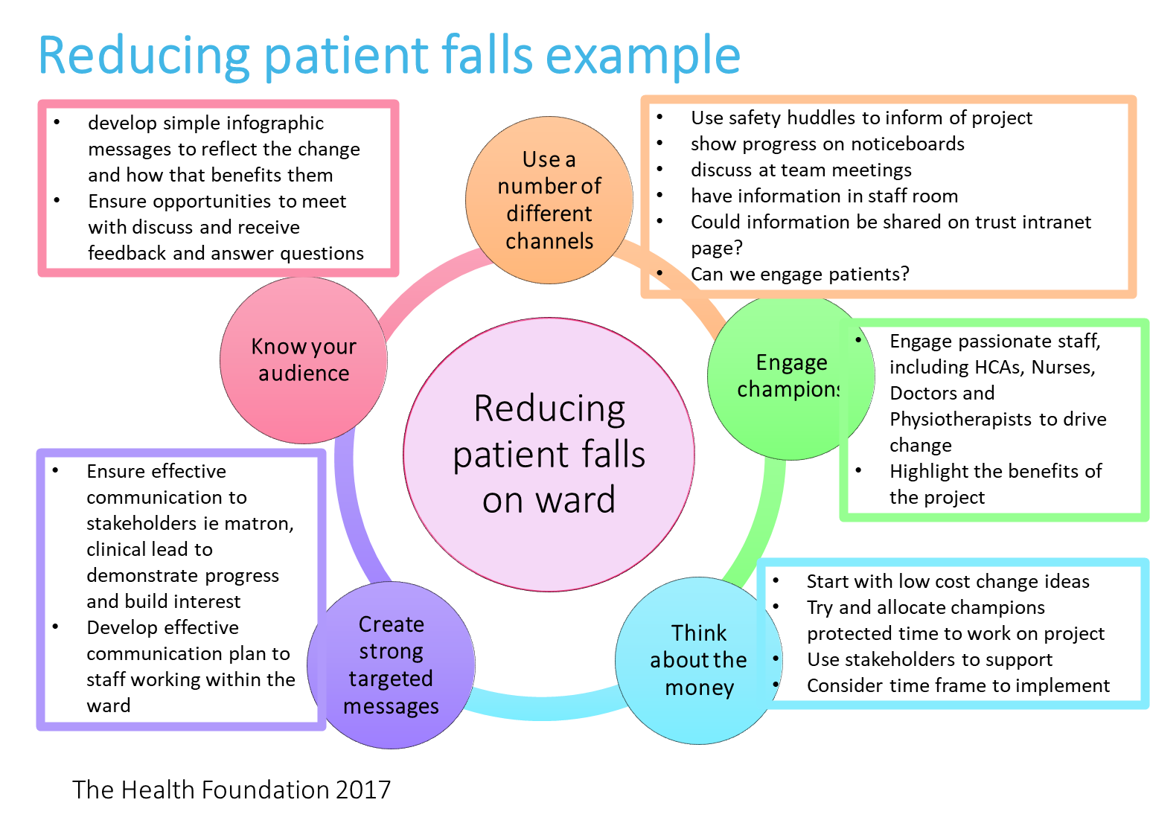
Its important to engage with your staff and communicate your project effectively to help facilitate improvement and to also sustain change. Here is an example of how a QI project maybe implemented on Ward X.

Stakeholder Analysis

High Power | Satisfy/ Meet their needs  - Engage on interest areas  - Increase level of interest  - Satisfy them with the project | Manage/ Key players  - Focused effort on this group  - Involve at all decision making  - Engage with regular communication and consultation
Low Power | Monitor/ Least important  - Only need to inform if have time  - Aim to move into the right-hand box | Inform/ Show consideration  - Make use of interest through involvement in low risk areas  - Potential supporter of project  - Patients would usually fall in this category
 | Low Impact | High Impact

Name | How much will the project impact them  (Low, Medium, High) | How much influence will they have over the project  (Low, Medium, High) | How will they contribute to the project? | How could they block the project? | How will you engage?

Process Mapping
Staff nurse Judith created a QI project team, and together they processed mapped the current pathway, to help identify how they could reduce patient falls on Ward X.

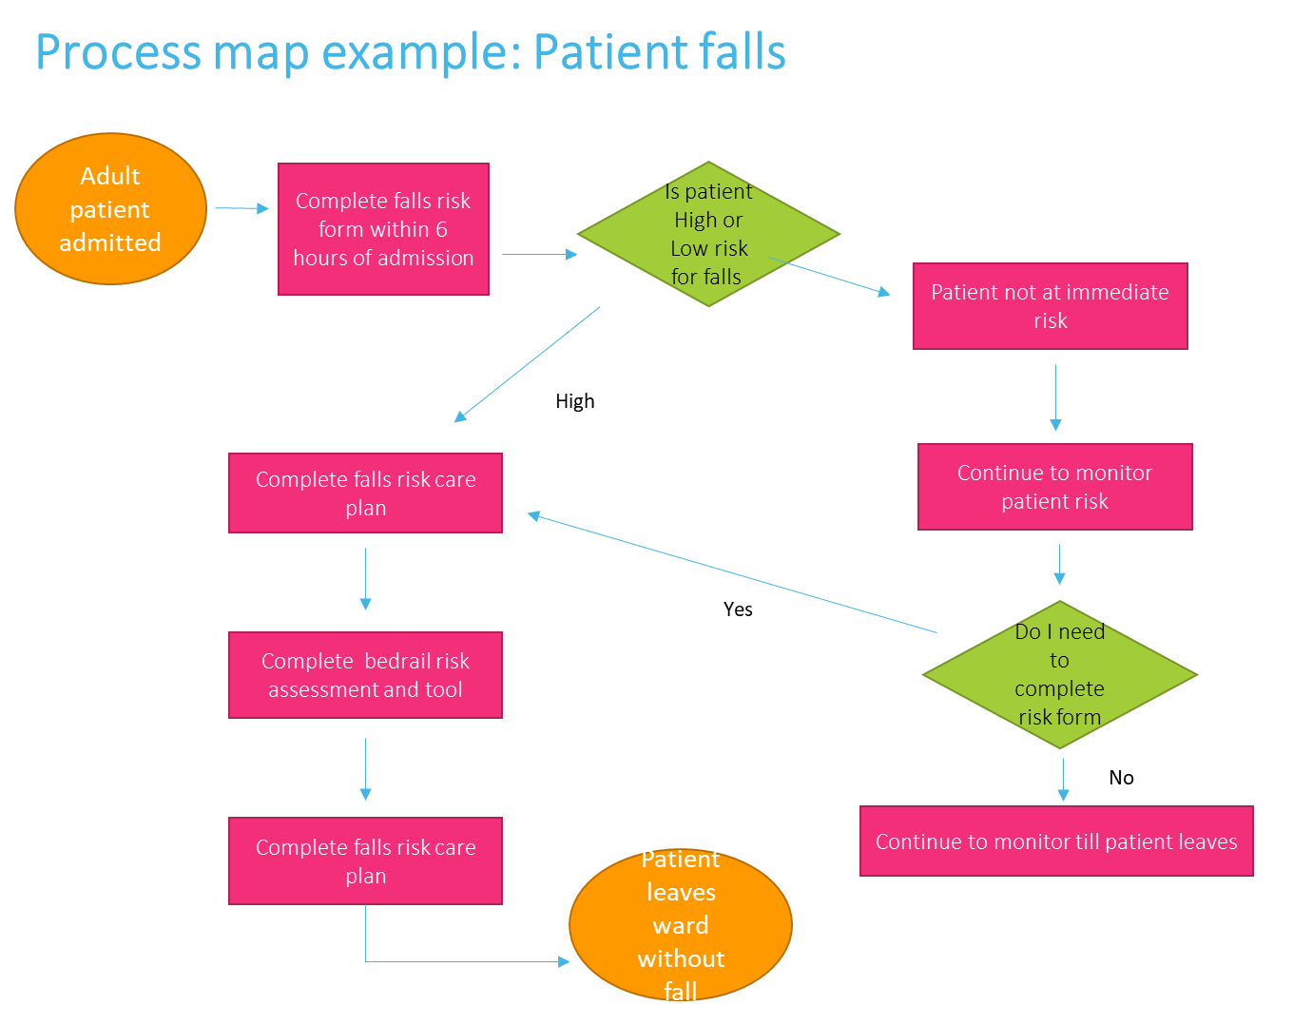

Creating an aim

SPECIFIC | Is the statement precise about what the team hopes to achieve?
MEASURABLE | Are the objectives measurable? Will you know whether the changes resulted in improvement?
ACHIEVABLE | Is this doable in the time you have? Are you attempting too much? Could you do more?
RELEVANT | Do you have the resources needed (people, time, support?)
TIME BASED | Do you identify the timeline for the project – when will you accomplish each part?

Creating a SMART aim
It is important the aim for the QI project is SMART. The aim for ward x is to ‘Reduce inpatient falls rate (per 100patient days) on X ward by 30% by 6 months​’.
Aim | Specific | Measurable | Attainable | Relevant | Time based
Reduce inpatient falls rate (per 100patient days) on X ward by 30% by 6 months​ | Reduce patient falls | By 30% | Yes | Yes (higher number of falls on the ward) | 6 months

Now write your SMART aim below:

Driver Diagram
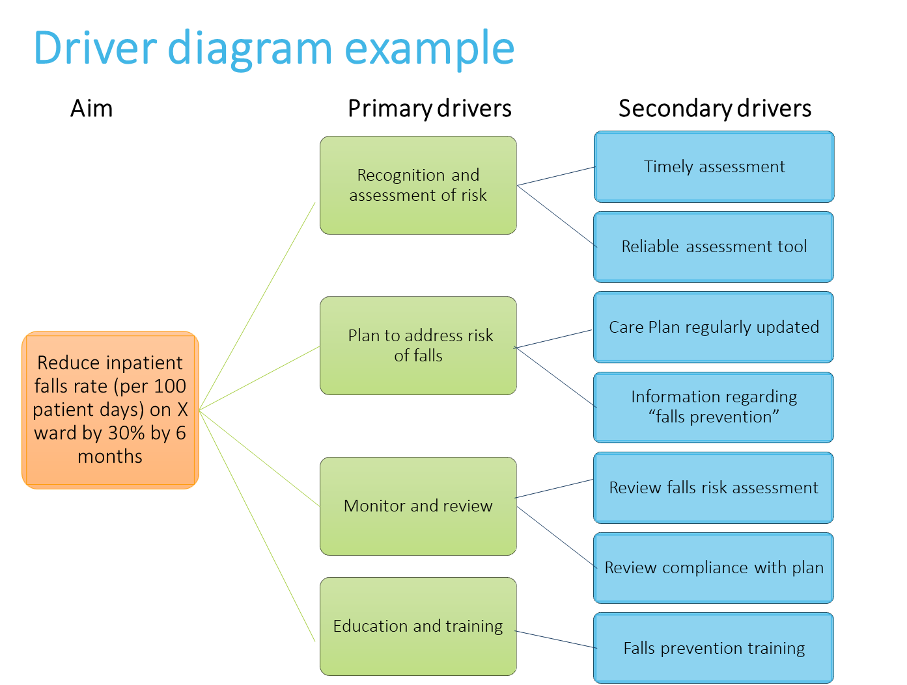
The team on Ward X have created the below driver diagram to help reduce the number of patient falls. A driver diagram can be considered a plan on a page of your QI projec
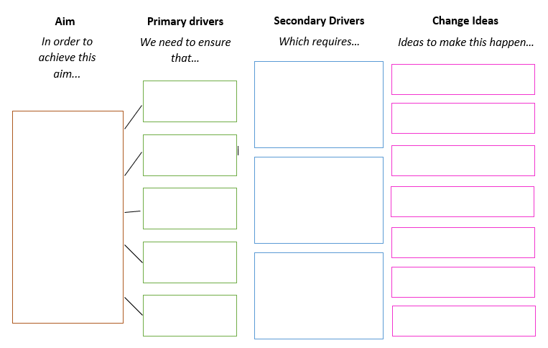

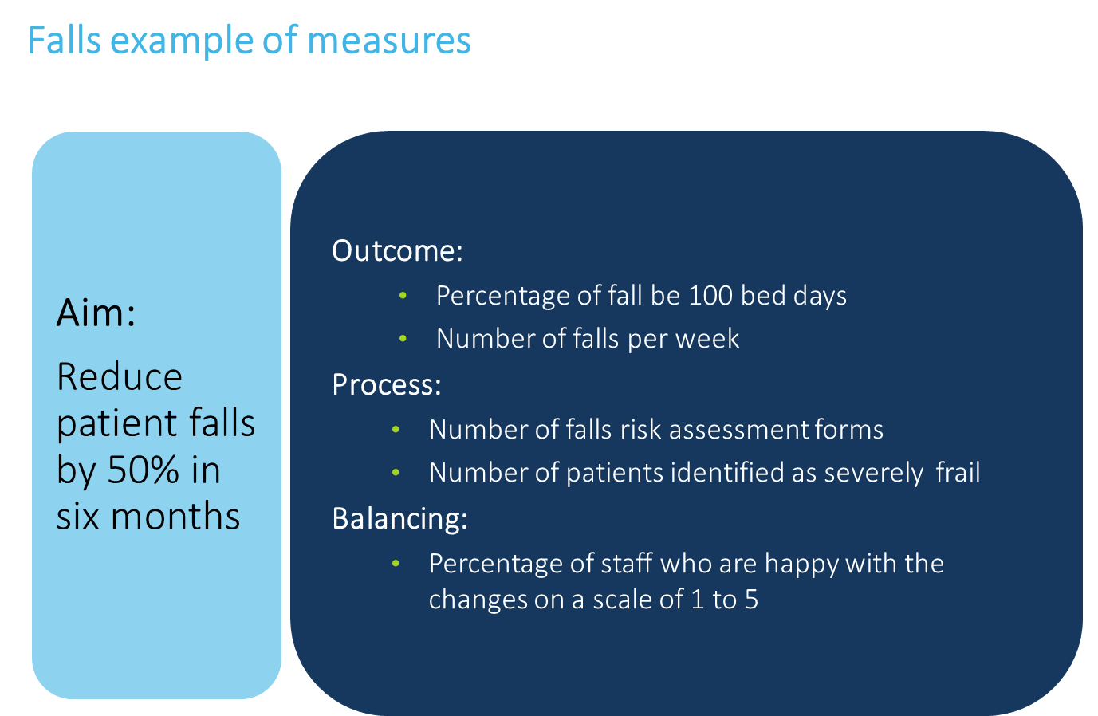

Measures
Measures are important to ensure we can assess if we are making an improvement or not. It is important to not have too many measures (no more than 6.) Here are Ward X’s measures.

Measurement
Three Types of Measures
Use a balanced set of measures for all improvement projects: outcome measures, process measures, and balancing measures.
Outcome Measures
Are directly linked to you aim, for example how does the system impact the values of patients, their health and wellbeing?
- For diabetes: Average haemoglobin A1c level for population of patients with diabetes
- For access: Number of days to till next available appointment
- For critical care: Intensive Care Unit (ICU) percent unadjusted mortality
Now write some outcome measures below:

Process Measures
Are the parts/steps in the system performing as planned? Are we on track in our efforts to improve the system?
- For diabetes: Percentage of patients whose haemoglobin A1c level was measured twice in the past year
- For access: Average daily clinician hours available for appointments
- For critical care: Percent of patients who have daily pressure sore assessments completed.
- For medication systems: percent of drug administration documented incompletely
Now write some process measures below:

Balancing Measures (looking at a system from different directions/dimensions)
Are changes designed to improve one part of the system causing new problems in other parts of the system?
- For reducing time patients spend on a ventilator after surgery: Make sure reintubation rates are not increasing
- For reducing patients' length of stay in the hospital: Make sure readmission rates are not increasing.
- Number of staff happy with the changes implemented.
Now write some balancing measures below:

NOTES

Run Chart Exercise
Identify the shift:
6 or more consecutive data points above or below the median. (Values that fall directly on the median are not included in this count and neither break nor add to a shift)

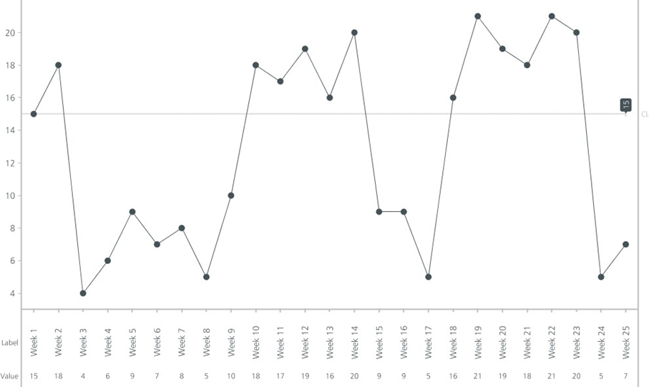

Identify the trend:
5 or more consecutive data points in the one direction. (Where the value of two or more consecutive points is the same, only include one in the count)
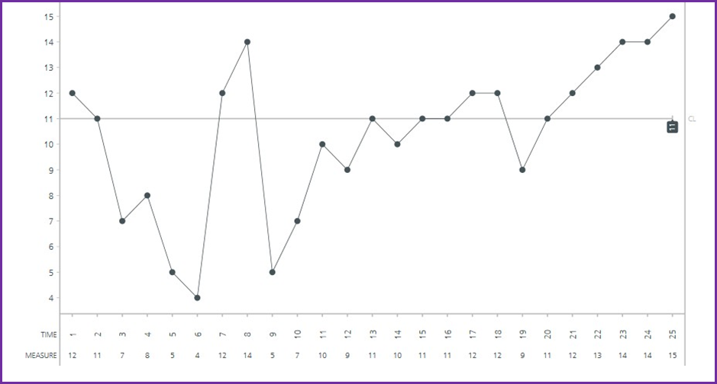

Identify the astronomical data point:
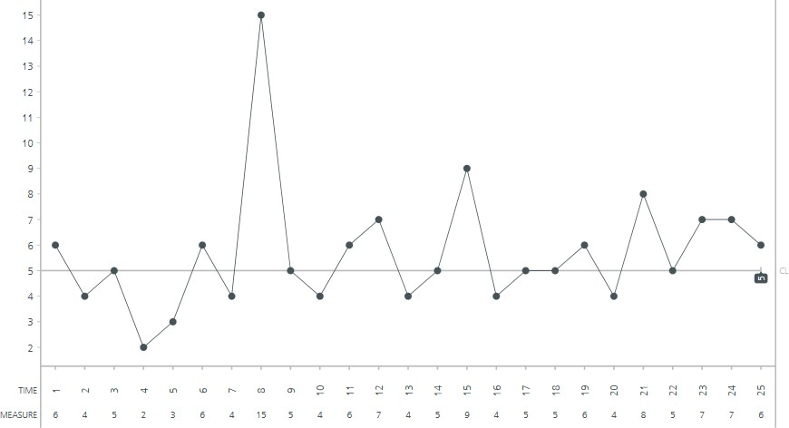
One data point is clearly different from all others.

Guitar game
NOTES

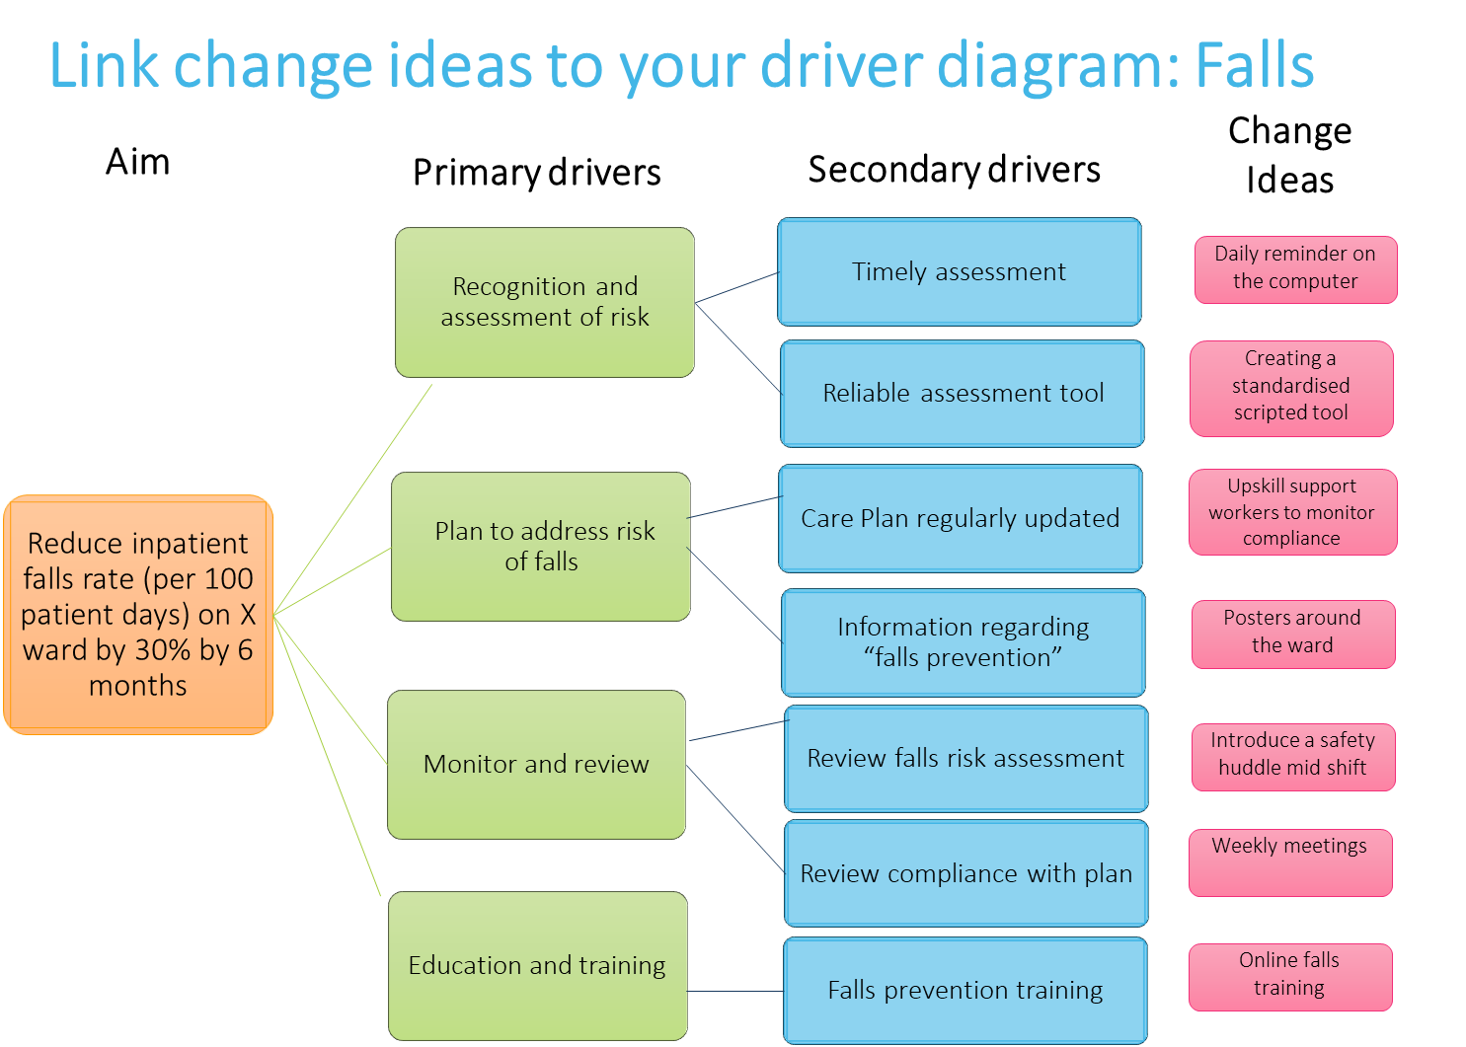
Change ideas Staff nurse Judith and her team have created the following change ideas to test on Ward X, after mind mapping and creative thinking as a team
DSA cycles
Here the Ward X QI team begin to test their change idea. The first PDSA cycle they want to initiate is online falls prevention training. Here is their documented PDSA cycle.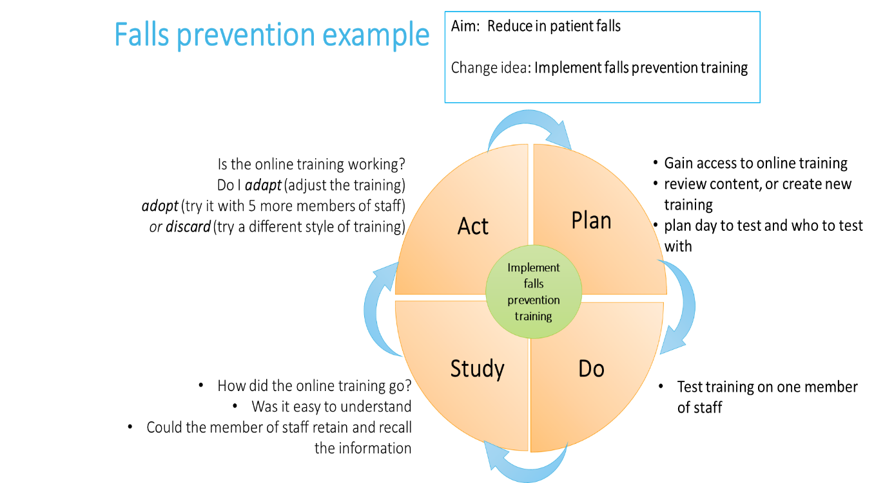

Linking PDSA cycles
Here is an example of multiple PDSA tests completed on ward X and the sequence of scaling up improvement.
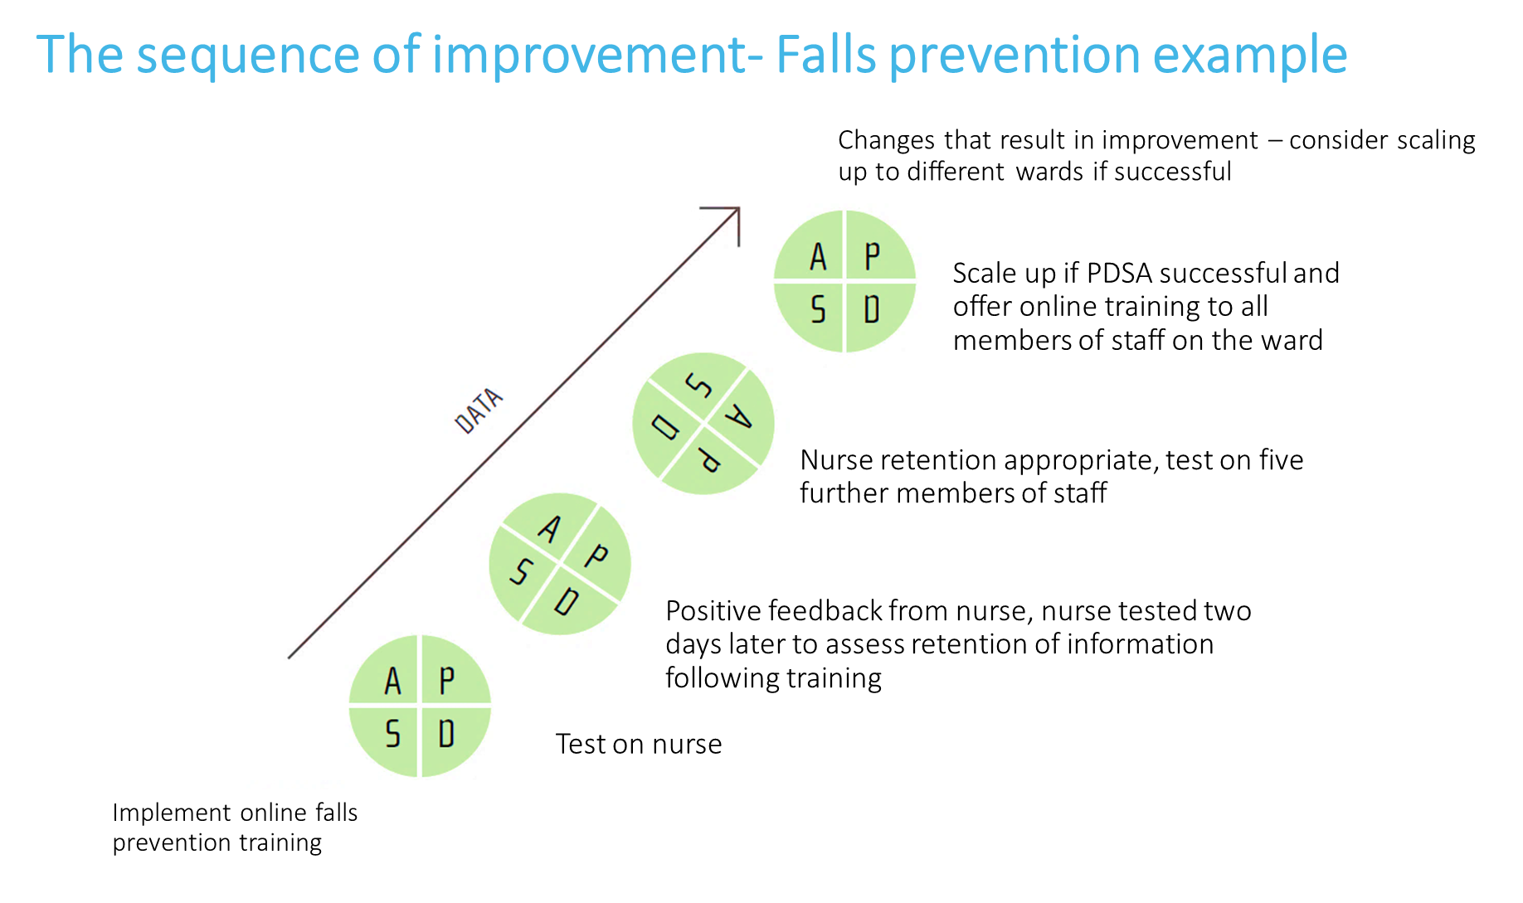

List the tasks needed to set up this test of change | Person responsible | When to be done? | Where?
Predict what will happen when the test is carried out (what do you expect to learn?) | How will you know whether the change is an improvement? (What will you measure and how?)
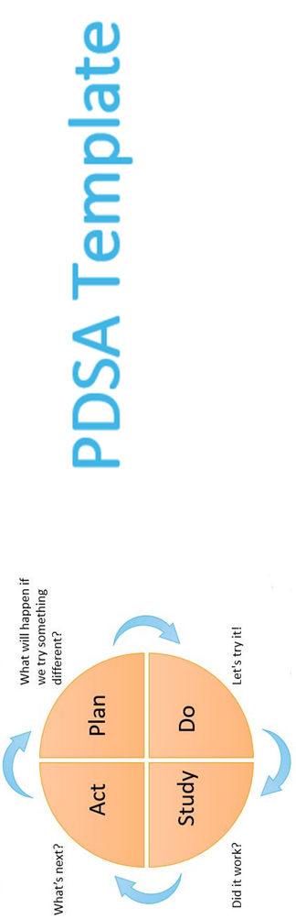
PLAN: Describe your test of change
What do you want to learn from this cycle?
What question do you intend to answer?

Do
Describe what actually happened when you ran the test. Note any unexpected events or problems.
Record any adjustment to the stated plan/analyse the data.

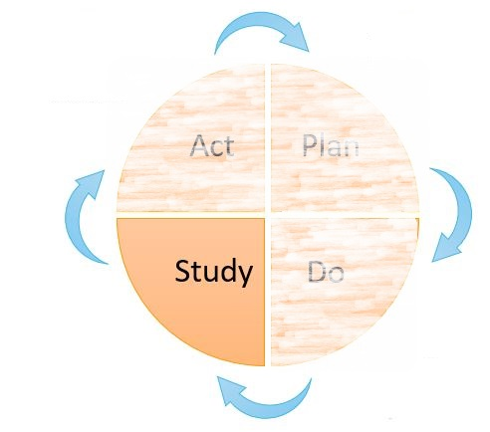
Study
Describe the measured results and how they compared to the predictions and what you learned from the cycle; what have you not learned?
Did your change lead to improvement? Why? Why not?
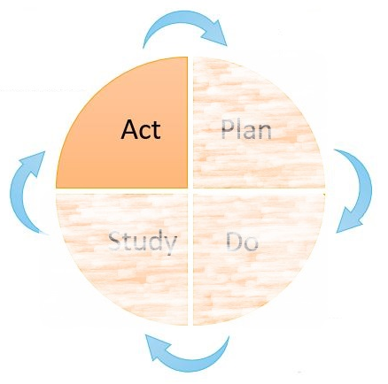
Act
Describe modifications for the next cycle based on what you learned. What are your next questions? What is your updated hypothesis?

Introduction to Quality Improvement by UCLPartners is licensed under a Creative Commons Attribution- NonCommercial-ShareAlike 4.0 International License. You must give appropriate credit to UCLPartners, provide a link to the license, and indicate if changes were made. You may do so in any reasonable manner, but not in any way thatsuggests the licensor endorses you or your use. You may not use the materials for commercial purposes. Click here for more info.
QI Team
E: QI@uclpartners.com
W: www.uclpartners.com
Mailing address:
3rd Floor 170 Tottenham Court Road
London, W1T 7HA
@UCLPartners #UCLPQI

