Introduction to Quality Improvement

Workbook

High
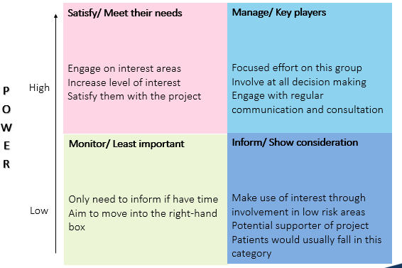

INTEREST

Low

Creating an aim

SPECIFIC | Is the statement precise about what the team hopes to achieve?
MEASURABLE | Are the objectives measurable? Will you know whether the changes resulted in improvement?
ACHIEVABLE | Is this doable in the time you have? Are you attempting too much? Could you do more?
RELEVANT | Do you have the resources needed (people, time, support?)
TIME BASED | Do you identify the timeline for the project – when will you accomplish each part?

Now write your SMART aim below:

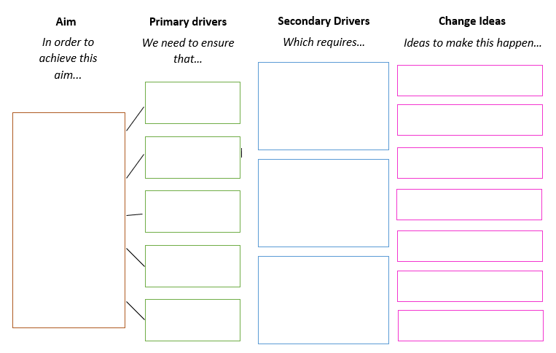

Measurement
Three Types of Measures
Use a balanced set of measures for all improvement efforts: outcomes measures, process measures, and balancing measures.
Outcome Measures
How does the system impact the values of patients, their health and wellbeing? What are impacts on other stakeholders such as payers, employees, or the community?
- For diabetes: Average haemoglobin A1c level for population of patients with diabetes
- For access: Number of days to 3rd next available appointment
- For critical care: Intensive Care Unit (ICU) percent unadjusted mortality
- For medication systems: Adverse drug events per 1,000 doses
Now write some outcome measures below:

Process Measures
Are the parts/steps in the system performing as planned? Are we on track in our efforts to improve the system?
- For diabetes: Percentage of patients whose haemoglobin A1c level was measured twice in the past year
- For access: Average daily clinician hours available for appointments
- For critical care: Percent of patients with intentional rounding completed on schedule.
Now write some process measures below:

Balancing Measures (looking at a system from different directions/dimensions)
Are changes designed to improve one part of the system causing new problems in other parts of the system?
- For reducing time patients spend on a ventilator after surgery: Make sure reintubation rates are not increasing
- For reducing patients' length of stay in the hospital: Make sure readmission rates are not increasing
Now write some balancing measures below:

NOTES

Run Chart Exercise
Identify the shift:
6 or more consecutive data points above or below the median. (Values that fall directly on the median are not included in this count and neither break nor add to a shift)

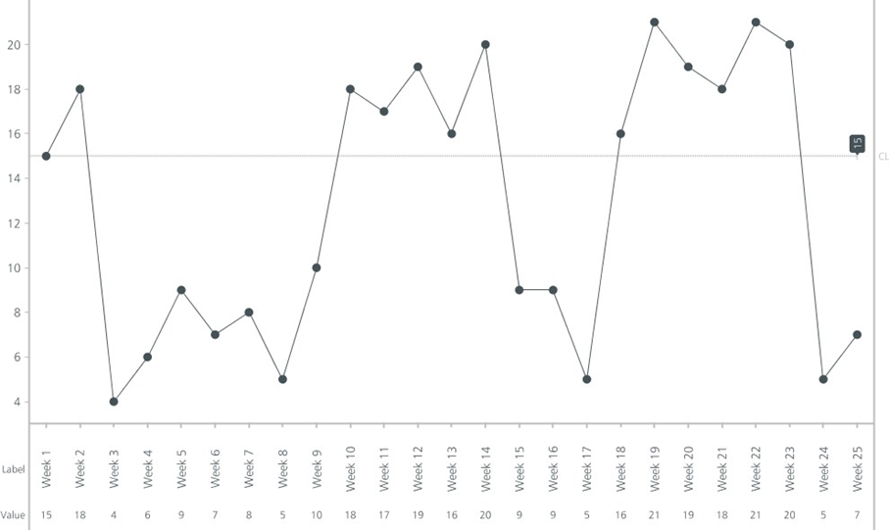

Identify the trend:
5 or more consecutive data points in the one direction. (Where the value of two or more consecutive points is the same, only include one in the count)
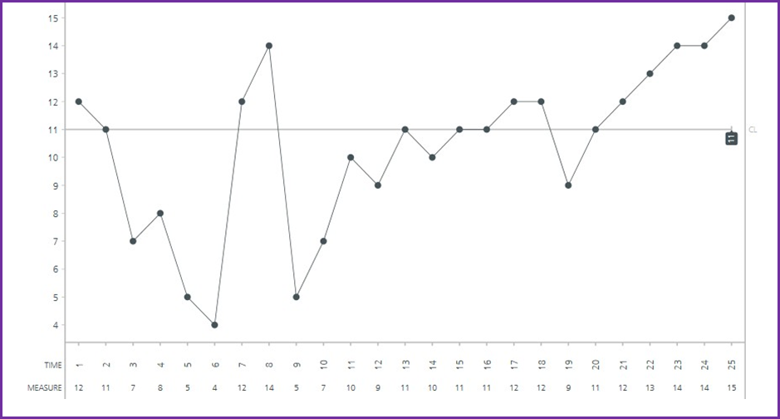

Identify the astronomical data point:
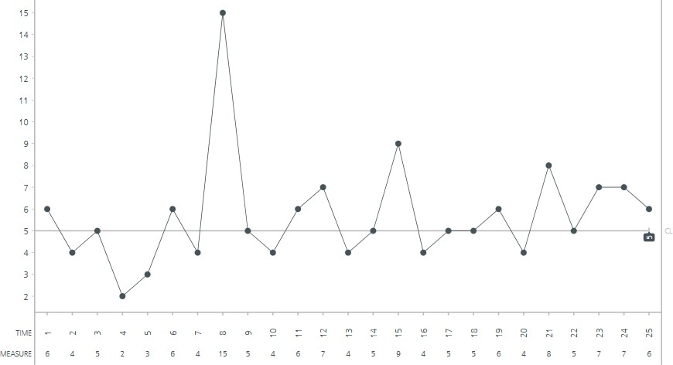
One data point is clearly different from all others.

NOTES

Guitar game

List the tasks needed to set up this test of change | Person responsible | When to be done? | Where?
Predict what will happen when the test is carried out (what do you expect to learn?) | How will you know whether the change is an improvement? (What will you measure and how?)

PLAN: Describe your test of change
What do you want to learn from this cycle?
What question do you intend to answer?

Do
Describe what actually happened when you ran the test. Note any unexpected events or problems.
Record any adjustment to the stated plan/analyse the data.

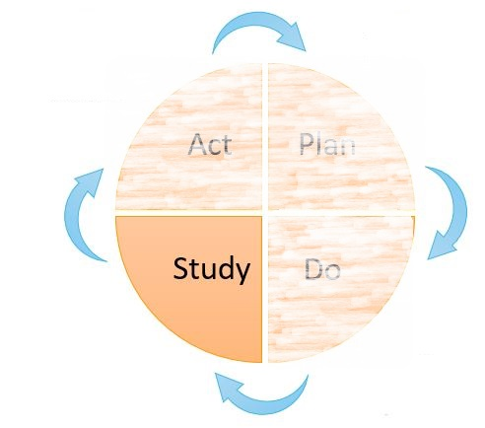
Study
Describe the measured results and how they compared to the predictions and what you learned from the cycle; what have you not learned?
Did your change lead to improvement? Why? Why not?
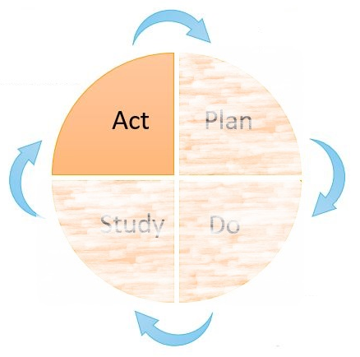
Act
Describe modifications for the next cycle based on what you learned. What are your next questions? What is your updated hypothesis?

Tennis Ball Game score sheet: theories and results
Use this sheet to record your test of change and data for the time taken and number of times the balls dropped.
Test of change  What are you going to do differently? | Time taken | No of times ball dropped

Introduction to Quality Improvement by UCLPartners is licensed under a Creative Commons Attribution- NonCommercial-ShareAlike 4.0 International License. You must give appropriate credit to UCLPartners, provide a link to the license, and indicate if changes were made. You may do so in any reasonable manner, but not in any way thatsuggests the licensor endorses you or your use. You may not use the materials for commercial purposes. Click here for more info.
QI Team
E: QI@uclpartners.com
W: www.uclpartners.com
Mailing address:
3rd Floor 170 Tottenham Court Road
London, W1T 7HA
@UCLPartners #UCLPQI

