Module 2: Team roles

UCLPartners Proactive Care Frameworks Implementation Workbook

Welcome
Welcome to module 2 – this will enable you to identify the individual roles and responsibilities of each team member in the implementation process of the UCLPartners Proactive Care Frameworks (the Frameworks). We understand the pressures that the primary care workforce is currently under and that implementing new processes can be met with resistance. The Frameworks offer the potential to increase capacity within the practice in the long term and contribute to fulfilling Quality Outcomes Framework (QOF) and improved patient outcomes.
Dr Matt Kearney, Executive Clinical Director for Cardiovascular Health, UCLPartners

There are a variety of roles within practices and Primary Care Networks (PCNs) which can support implementation of the Frameworks. A core principle of the Frameworks is for them to be adapted to local needs based on your workforce capabilities and patient requirements. So, as the project lead, how do you go about assigning roles and responsibilities and how will you motivate your team? This module will cover these topics to set you up for success to achieve your local objectives.

Getting the most out of this document

Time to complete module:
30-60 minutes

FutureNHS
You can talk to other users of the workbook in our discussion forums on the FutureNHS platform. To access these discussion forums, you will need to visit https://future.nhs.uk/ and register with your email address. Once logged in, search for the Primary Care discussion forum: Proactive Care Frameworks or scan the QR code and request to join the group. Once approved, you will be able to share your experiences of these resources with your peers.

Learning objectives
- Explain the workforce benefits of using the UCLPartners Proactive Care Frameworks
- Identify the tasks involved in completing the Frameworks and how your team can support implementation and delivery
By the end of this module, you should be able to…
Develop a workforce implementation plan and assign roles and tasks to your team.
Key terminology
Additional Roles Reimbursement Scheme (ARRS): The scheme was introduced by NHS England in 2019 to provide funding for PCNs to recruit additional staff to meet the DES and deliver the NHS Long Term Plan. ARRS roles include community paramedics, care co-ordinators and physician associates.
Clinical Pharmacist: The role works as part of the general practice team. It includes providing advice on managing long-term conditions, recommending treatment optimisation and performs health checks.
Healthcare Assistant (HCA): Members of the care team who are trained to undertake specific clinical procedures and support patient care.

Pharmacy Technician: Under a pharmacist’s supervision, a pharmacy technician can administer and perform medication risk assessments. This role is becoming more integral to primary care by preparing repeat prescriptions, medication audits and patient advice.

Physician Associate: Physician associates are medically trained, generalist healthcare professionals, who work alongside doctors (usually in primary care) and provide medical care as an integral part of the multidisciplinary team.

Primary Care Network (PCN): PCNs are groups of GP practices working more closely together, with other primary and community care staff and health and care organisations, providing integrated services to their local populations.

Proactive Care: Having the processes, access to data and the workforce in place to take a proactive approach to patient care. Proactive care underpins the UCLPartners Proactive Care Frameworks.

UCLPartners: The partnership organisation that developed this workbook and resources. UCLPartners works with academic and NHS partners to improve health and care through research, innovation and education for the benefit of patients and the public.
UCLPartners Proactive Care Frameworks (Frameworks): The collection of resources developed and collated by UCLPartners to support primary care identify, prioritise and optimise care of patients with long term health conditions.

Contact Us
If you have any questions regarding this workbook, please contact us at: primarycare@uclpartners.com
We’d love to hear your views on the content in this module, please do provide feedback via the link at the end of this document.
Table of contents
The pathway to better patient outcomes 5
Roles and responsibilities 5
Identify who needs to be involved and what their role will be 8
Process Flow 8
Flexibility 10
The roles 10
Project Lead 10
Clinical roles 11
Clinicians, Nurse practitioners and Prescribing clinicians 12
Clinical Pharmacist, Nurse and Physician Associate 12
Health Care Assistant (HCA) and similar roles 13
Case studies 14
Discussion exercise: Do my team need support? 15
Module Summary 17
Feedback 17

Benefits of using UCLPartners Proactive Care Frameworks
- The Frameworks and resources are designed to help clinicians do things differently in the real world of modern, complex general practice where patients have multimorbidity and consultations are time pressured.

- Using the stratification tools to prioritise patients who are at highest risk or poorly controlled helps practices achieve Quality Outcomes Framework metrics and local incentive targets as well as new indicators in the Directed Enhanced Service and the Investment and Impact Fund.

- The Framework resources include pathways and protocols for local adaptation together with training and implementation guides, case studies and digital tools. These will help staff such as healthcare assistants, wellbeing coaches and other additional roles to provide proactive care for patients - with structured support for education, self-management and behaviour change.

- Overall, the clinical prioritisation and systematic use of the wider workforce helps teams to optimise patient care, safely manage workflow, free up GP capacity and increase job satisfaction for staff.

The pathway to better patient outcomes

Roles and responsibilities
The Frameworks help to provide proactive care and targeted treatment for patients, enable staff to signpost the right patient to the right team and take an integrated approach to care delivery. To utilise the UCLPartners Proactive Care Frameworks, each team member is vital in performing their task which in turn has an impact on the patient’s outcome. There are a variety of roles within your practice that could be involved in delivering the Frameworks.

The purpose of these roles can vary from delivering care to a specific priority group to developing new skills to offset the pressure on physician-led appointments. This guide will help you to identify the types of interventions and roles required so that you can do what you can with the staff you have to bring about impact!
Below are findings from a study by the Centre for Healthcare Innovation Research who evaluated the impact of the Frameworks on the workforce:
The Frameworks have generally been welcomed by PCNs/practices, particularly by clinicians, as a valuable improvement in long term condition management. The risk stratification process was highlighted by the primary care workforce as a very useful new way of ensuring that patients receive the right care at the right time. The Frameworks were perceived as providing an appropriate structure supporting the introduction and integration of wider workforce roles, and as supporting both the operationalisation of the personalised care agenda and the transition towards a more holistic care approach.

Optional: Scan the QR code or click the plus icon to read the full findings from the study

Here’s an example of how a multidisciplinary team can provided a holistic approach to patient care:

A patient was referred to the health coach to help with self-management and monitoring of his hypertension. He had not been seen in two years and disclosed that his diet had been poor and he had not managed much exercise over this period. The wellbeing coach referred him to a pharmacist who organised a cholesterol test. He was recommended statin therapy because of a high cardiovascular risk score and was given British Heart Foundation resources around healthy eating and exercise.

Patient information

Medical assessment
Medical advice

Use of the wider workforce

As you can see, the Frameworks use a combination of medical advice and assessment, patient resources and when appropriate, use of the wider workforce to deliver proactive care to a community of patients with long term conditions.
Whilst this integrated approach might seem daunting at first, this workbook will help you to identify the workforce roles and responsibilities that need to be allocated for the success of this programme.
‘Utilising an integrated team means that the patients are benefitting from a multidisciplinary approach to their care. One of the legacy pieces from this work will be multi-disciplinary team meetings for the Physician Associates to feed back into.’
Physicians Associate, North-West London.
Optional: Read the full case study by scanning the QR code or clicking the plus icon

Reflect on: What could the benefits be for you and your team if your practice adopts the Frameworks? Use the space below to record your thoughts.

Activity: Complete a process map on how your team currently provides care for patients with a long-term condition e.g. hypertension. Use the template on the next page.
This quality improvement tool helps to identify areas for improvement in the current pathway and can be used to map out and understand new pathways. It’s best to complete the activity as a team or with help from your AHSN who might be able to support you, to capture the perspectives and tasks from the roles involved.
Start/Stop
Activities and owner
Decision
Flow line
3) Take the process step by step. Identify the activities involved and who does them, decision points and the flow of the process
4) Consider running this activity with post-it notes in a multidisciplinary meeting to fully understand the process. Look for opportunities for improvement.

Process Mapping Steps

- The pathway being mapped is (be as specific as you can):
- Identify the start and end point of your pathway and write these in the ovals e.g. Start: Patient calls practice in their birthday month to book annual review End: Clinician updates patient record

Symbols

What is the process that you want to influence and improve? Make sure that it is clearly stated the process you are referring to
Project Title: How your team currently provides care for patients with a long-term condition e.g. hypertension?
Where does your process start from?

Identify who needs to be involved and what their role will be

Below is a flow chart detailing some of the main roles that may exist within your practice that could complete each task. The roles identified are recommendations and can be changed based on your workforce.

Process Flow
Recommended roles for stratification

Intervention

An example from our trial sites demonstrating how different workforce groups were involved between practices in implementing the Frameworks is shown below:

Workforce group | Practice 1 | Practice 2 | Practice 3 |  | Practice 4
GP | x | x | x | x
Practice nurse | x | x | x | x
Advanced nurse practitioner | x |  | x | x
Nursing assistant/associate | x | x
Clinical pharmacist | x | x | x | x
Healthcare assistant | x | x | x | x
Social prescribing link worker | x
Care coordinator or health and wellbeing coach | x |  | x
Administrative roles | x | x | x | x
Other | Community pharmacist |  | IT consultant
Source: CIHR 2022
Reflect on: Who do you have within your practice that could help with these roles? Use the space below to record your thoughts.

Project manager:
Running the searches:
Tasking the outcomes:
Sending invites:

High risk intervention:
Medium risk intervention:
Holistic care:

Flexibility
The Frameworks can be used in various ways depending on the results of the stratification process, the team’s capacity and capability and the population health needs. The case studies above highlight how different roles within the team can be utilised with different priority groups. This multi-disciplinary approach enables the redistribution of work across all primary care staff for long-term condition management.
The wider primary care workforce (e.g. pharmacists, healthcare assistants and social prescribers) can be involved in patient care for patients across all priority groups (if needed) to reduce pressures on GP’s. Using the wider workforce to support education, self-management and behaviour change will improve the care offered to patients and will reduce demand for clinician time.
Now that you have a rough idea as to the process flow of PCFs, we will now perform a deep dive into the roles and responsibilities of the workforce.

The roles

Project Lead
The role of the project lead is rewarding and challenging. Anyone within a practice or PCN can take on the role and should be supported by senior colleagues. As project lead, it is recommended that you:
- Complete the workbook modules to develop your knowledge of the Frameworks
- Access external peer support and resources from your local Academic Health Science Network (AHSN)
- Highlight the Framework resources and benefits to your team
- Work with your team to adapt the process to best meet your needs of the practice and the population
- Support the team through leadership and problem-solving skills

Tip: These modules will prepare you to lead the implementation of the UCLPartners Proactive Care Frameworks.

Clinical role
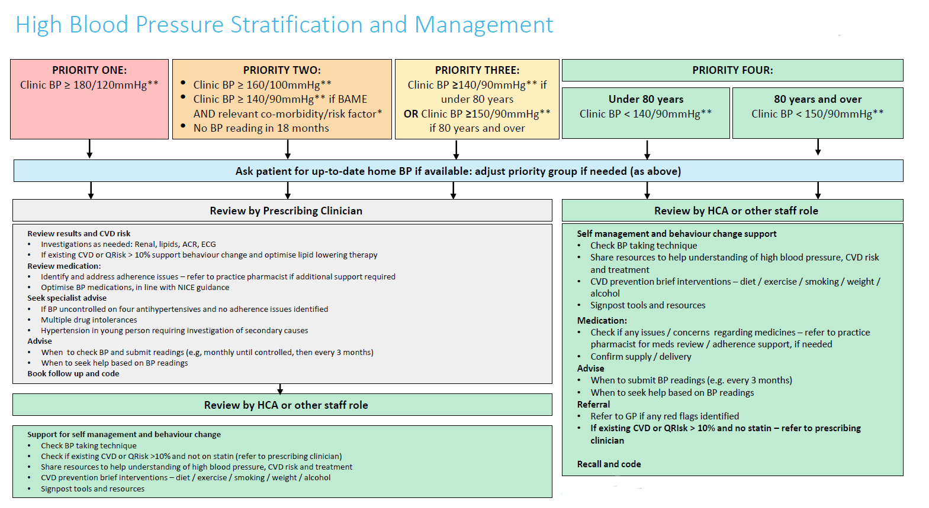
There are many interventions that could be performed by the clinical team during a review. An example of the different interventions by priority group for hypertension management is shown below:

Prescribing clinician
In all the Frameworks, those in the highest priority groups will require a medical intervention/assessment performed by a prescribing clinician with support from the wider workforce. This is presented in the following examples:

Tip: A core principle of the Frameworks are that these interventions are performed remotely where appropriate and face-to-face when needed.

Clinical Pharmacist, Nurse and Physician Associate and similar roles
These individuals could review patients in the medium priority category in some of the Frameworks, depending on their competency.
Their role can involve:
All staff involved will need to be equipped with the right knowledge and resources to be able to deliver the care as proposed. This may mean ensuring they are aware of local schemes to provide digital equipment for patients and have access to patient educational resources (a curated list is provided in the Frameworks).
Reflect on: How could you support your team with these potential barriers? Are there any other issues that you think will become barriers?

Healthcare Assistant (HCA) and similar roles
HCAs and other roles can be involved in all priority pathways through the provision of holistic care. Additional roles could be support-workers, social prescribers, link workers, care co-ordinators and health and wellbeing coaches.

Resources to support HCAs and other staff delivering proactive care
As some of the above tasks might be typically outside of the usual HCA and other staff roles such as behavioural support. Protocols and training are currently available which provide this. Additionally, a specialist workbook module is being created to support HCA’s and similar roles with delivering their interventions.

Use of the wider workforce is dependent on skillsets and experience. Staff must be supported to work differently, and clear escalation and handover protocols need to be in place. Your local Training Hub may be able to provide some of the workforce training required.
‘By doing all of this [the Frameworks] we are promoting an integrated approach to health care, improving patient care… and improving the way we do our jobs, and as a result of all this we are really addressing the health inequalities in Newham and the major concern being cardiovascular diseases.’
Health and Wellbeing Coach, Stratford PCN

Case studies
Watch these two case studies and reflect on who you could allocate within your team to perform each function and the support that they would require.
A GP and Health and Wellbeing coach perspective, Newham, East London
Join Dr Vaishali Ashar and Darshana Lathigra from Stratford PCN as they share their experiences of using the Frameworks.

Use of the Frameworks to manage CVD Prevention
Join Helen Williams, National Speciality Advisor for CVD Prevention, NHS England as she talks through an example patient pathway for cholesterol management and blood pressure optimisation.

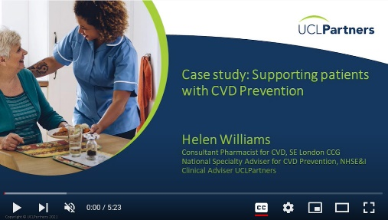

As you can see from the above, utilising the whole team will facilitate a multi-disciplinary approach to managing hypertension, taking into account the medication, behavioural and lifestyle choices that can lead to deterioration.
Whilst hypertension might not be the Framework that your practice wishes to implement first, the core structure of the workforce roles and responsibilities is the same

Reflect on: What are the potential challenges that you anticipate with this new approach and what are your sources of support?

Challenges:

Sources of support:

Discussion exercise: what support do you need as a team?
What support will your team need to use the risk stratification searches and redistribute the work in this way?
Share your thoughts in the discussion forum.

Activity: Complete a second process mapping exercise to work out how your team could use the Frameworks from stratification to intervention to optimising patient care. What do you anticipate the steps involved will be when setting up this pathway? More information about using the risk stratification search will be given in module 3.

Your local AHSN team might be able to support you with the implementation of the Frameworks for example by facilitating a process mapping activity with you. To find out how to contact your local AHSN and see what support they might be able to offer you, go to: https://www.ahsnnetwork.com/

Start/Stop
Decision
Activities and owner
Flow line
3) Take the process step by step. Identify the activities involved and who does them, decision points and the flow of the process
4) Consider running this activity with post-it notes in a multidisciplinary meeting to fully understand the process. Look for opportunities for improvement.

Process Mapping Steps

- The pathway being mapped is (be as specific as you can):
- Identify the start and end point of your pathway and write these in the ovals e.g. Start: Patient calls practice in their birthday month to book annual review End: Clinician updates patient record

Symbols

What is the process that you want to influence and improve? Make sure that it is clearly stated the process you are referring to
Project Title: How your team currently provides care for patients with a long-term condition e.g. hypertension?
Where does your process start from?

Module summary
Well done for completing Module 2! You have reviewed how your team works and the changes that will need to be made to implement the Frameworks.
In the next module you will learn about the UCLPartners risk stratification approach.

Feedback
We’re keen to hear your feedback about this module. Please complete the online survey here: https://forms.office.com/r/i1fxPs9q0x

Sign up to receive the UCLPartners Proactive Care Newsletter
to find out when new modules are released.

