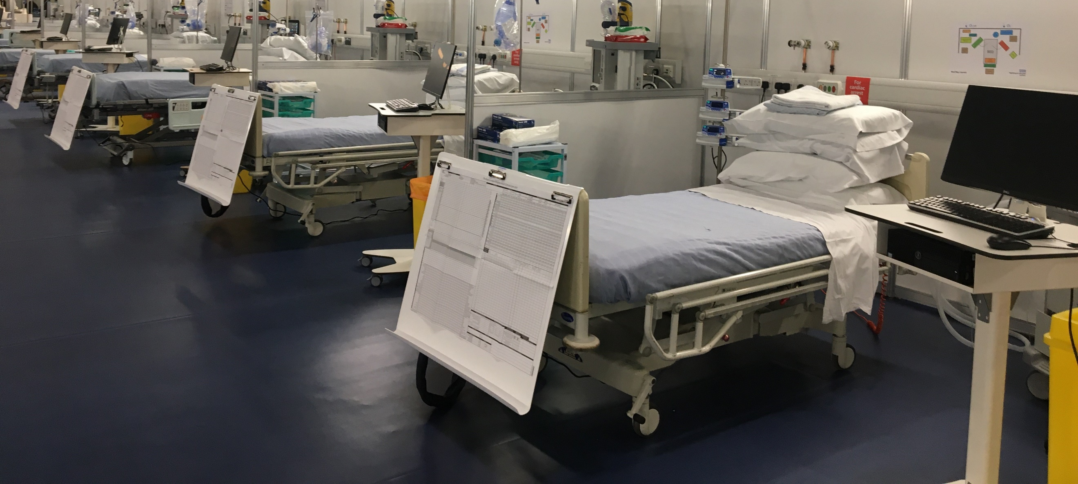
Bedside Learning Coordinator (BLC) Handbook
Quality and learning team
May 2020

The Bedside Learning Coordinator is a new role at NHS Nightingale Hospital London. It was created to support the Nightingale learning system across clinical, workforce and operational domains to enact meaningful change in clinical service provision via a direct and effective two-way feedback and improvement mechanism between front-line staff and workstreams leads.
This document provides the background for the role, the context in which it works and details of the job description, duties, and observation forms.

Contents
1. Background 2
2. The BLC role 2
3. Recruitment and rostering 3
4. Accountability and team structure 3
5. Outline of BLC Duties 4
6. Job Description for Bedside Learning Team Leader NHS Nightingale London 6
7. Job Description for Bedside Learning Coordinator NHS Nightingale London 8
8. BLC observation form 10

Bedside Learning Coordinator

Background
NHS Nightingale London is a learning system. For patient, family, staff and wider NHS benefit, we are committed to learning fast and acting fast across all dimensions: clinical, operational, and staff wellbeing.
The learning system supports focused uncertainty reduction by capturing qualitative reports from the front-line and integrating these with quantitative analyses of Nightingale data, and external research and insights to find better ways of providing and supporting care.
The learning system is based on the following five principles:
- identify known areas of uncertainty
- help the caregiver to help the patient
- reduce the burden on front-line clinical staff
- learn from every patient
- associate all important practice changes with a rapid feedback loop
The physical constraints of the environment between the clinical area and the rest of the hospital makes direct observation during clinical shifts challenging. In addition, the role of staff on the ward is physically and mentally demanding, making recall of suggestions for improvement at the end of shift unrealistic and unreliable. As such we designed a new role, the Bedside Learning Coordinator (BLC), to enable real-time observation and feedback from the bedside, and an opportunity to take learning and changes back to the bedside as quickly as possible.

The BLC role
The BLC has a dual role. First, the BLC works with staff on the floor to capture their insights into what is working well and what is not and supports staff in reporting of and debriefing after incidents. This qualitative data source complements other data sources for monitoring the performance of clinical and operational processes. Second, the BLC takes changes arising from external advice or internal redesign and reminds staff of new ways of working, educating them in real-time at the bedside. Through these two mechanisms learning is simultaneously directly captured from daily patient care and turned into immediate action – with rapid feedback on impact. In addition, the BLC undertakes occasional focused audits of changes to confirm on the ward that the improvement is implemented, is satisfactory to staff, and is permanent.
Suggestions from the bedside and the implementation of changes developed in response are tracked with a specially developed "Quality and Learning Tracker". This tracker helps to triage insights into three areas: Fix (requiring immediate action), Improve (suggestions for better ways of doing things that are already done), Change (substantial changes to care that is delivered or a new or different way of doing something that has not been done to date). These actions are then triaged to operations, training and education and clinical teams. This database is used to inform various working groups and decision forums.
The following underpinning components need to be in place to get full value from the BLC role:
- Supernumerary – focusing on providing direct patient care will detract from their ability to observe care delivery, consider solutions and enact service change.
- Independent – explicit and implicit obligations to existing groups will act as barrier to impartial and honest feedback, learning and improvement.
- Patient-facing –observing and gaining insights from front-line staff and their patients is critical to ensure accurate and timely observations as well as effective care solutions
- Multi-professional – recruitment of BLCs from diverse backgrounds allows for diverse observations and for specialist input into areas for improvement
- Empowered – giving BLC teams the confidence to observe care, survey staff, consider solutions and inform management ensures that care improvements are optimised.

Recruitment and rostering
There are two sources of recruitment to BLC shifts. First is the core faculty that are expected to cover 80% of the shifts. These are individuals specifically recruited as BLCs. They may be working elsewhere in the hospital, for example in the training and education team, or working as clinicians in other trusts. Secondly, leaders and staff from across the multi-professional teams are encouraged to complete BLC shifts to enhance their reflection and understanding of opportunities for improvement from the floor. At the end of phase one, for example, one shift per week was covered in rotation by Occupational Therapists from the step down team, and another shift per week was covered by members of the compassionate care team. Quality and Learning team members were also encouraged to complete shifts on the floor to enhance understanding and refinement of the BLC role and wider hospital learning process.
Each BLC covers one 126 bedded zone, which consists of 3 wards. This is the same footprint as Matrons. At the end of phase 1 there were 2 shifts per day, 7 days per week:
- 10am – 4pm
- 6pm - midnight

Accountability and team structure
The BLC team provide assurance, information and solutions to the Quality and Learning team, who in turn triage actions to the appropriate workstream leaders of decision authority groups to ensure rapid action and implementation within the Nightingale Hospital London.
Each rostered BLC is accountable to the BLC team leader who works within the Quality and Learning team.

Outline of BLC Duties
An overview of the typical duties of a BLC

Going onto the shift
Understand the key messages for that day
- meet BLC team pre shift for shift brief and/or receive written handover
- review the board next to the entrance to the ward
- discuss with Tactical Operations lead at shift sign-in

Ward round: at each bed
Check in with the ward matron at the beginning of a shift to ensure they know you are there and can brief you on any priorities for the day (concerns or improvement opportunities)
Interview people working on the floor
- use open ended questions
- what have you learnt today that you wished you had known at the beginning of the shift/project?
- what problems are you encountering (clinical and operational)?
- what suggestions do you have for ways to address clinical, operational, training and workforce issues?
- what ideas do you have for doing things better?
Inquire about
- individual staff member's wellbeing and reinforce access to psychological support
- alert and remind staff that clinical and operational changes have happened since yesterday
- where there are key issues of concern / areas to be on the lookout for of the key messages of the day
Audit to assess
- key quality issues - core audits
- implementation of changes approved by the relevant change authority - discretionary audits
- encourage staff to input incident reports into DATIX, support debriefing with staff and ensure the matron is alerted to all incidents that have been logged (either immediately or at the end of the shift, as appropriate)
Record
- staff ideas and suggestions on BLC form
- your own impressions, making sure these are identified as your observations
other duties during the round
- assist the Matron and shift leadership team to ensure that approved actions are successfully implemented
- provide any other assistance to the Matron and shift leadership team as needed
- discuss content of BLC sheet with Matron during shift to validate content
- implement on the spot fixes as appropriate and in collaboration with the Matrons and shift leadership team
- feedback information on changes/fixes already in progress to staff on shift

At the end of the shift
- debrief with the matron and share final observations sheet
- scan BLC form to self and BLC team
- debrief with the Quality and Learning team

Other duties
Attend 4pm hospital meeting to gain insight into running of hospital and how changes are decided on/progressing
Participate in the Quality and Learning team to feed insights back and help in evaluation, redesign and action distribution

Job Description for Bedside Learning Team Leader NHS Nightingale London

Reports to
Quality and Learning Team
Job Summary
To co-ordinate, debrief and liaise with the team of Bedside Learning Co-ordinators (BLCs) to identify, prioritise and drive continuous quality improvement in a quickly evolving clinical area. Working collaboratively with a range of clinical and support elements of the team to facilitate decision making and problem solving in order to develop the NHS Nightingale clinical team from an emergency task force to a centre of best practice in ITU care of Covid-19 patients.
Key Tasks
- Co-ordinate the collection and review of multidisciplinary feedback from clinical area, significant events and patient feedback.
- Assist in categorisation of feedback to key work streams.
- Contribute to the development, planning and organisation of the continuous improvement in care delivery.
- Support the facilitation of learning into practice including promoting a positive learning environment, developing opportunities to embed changes of policy into clinical practice and develop communication strategies to disseminate information to all stakeholders.
- Maintain records of bedside learning concerns.
- Produce regular reports on results of fixes, improvements and changes and audit clinical activity to confirm changes have been successful.
- Identify and recruit new BLCs to promote a wide skill mix in team enabling learning from a wide range of perspectives.
- Produce and manage a rota of staffing to ensure BLC availability as required by changing clinical environment.
Person Specification
Factors | Essential | Desirable
Qualifications | - Registered Healthcare Professional | - Critical care experienced registered nurse
Experience | - Experience within a healthcare governance & quality improvement role  - Experience of introducing a significant change within a practice setting | - Experience of delivery of training and education in a practice setting
Specific Skills and Knowledge | - Leadership, communication and interpersonal skills including presentation, influencing, negotiation and complex report writing  - Ability to proactively identify new initiatives, justifying and implementing them as clinical need demands | - Working knowledge of principles of quality improvement, education and governance  - Clinically current in high dependency/critical care environment
Personal Attributes | - Able to communicate across all levels of the multi-disciplinary team  - Proven team player  - Physically fit without significant health concerns and able work in an environment with Covid-19 positive patients | - Able to commit to FTE post for minimum of six weeks (would consider a job share if no suitable FTE person available)

Training Required
- PPE Training minimum (could complete full induction)
- Familiarisation with NHS Nightingale daily routine
- Familiarisation with Bedside Learning Coordinator shift observation form
- ImproveWell App
- Perfect Ward App training and reporting
- Datix training and reporting
- Familiarisation with Weshare and accessing policies, procedures and Quick Reference Guides

Job Description for Bedside Learning Coordinator NHS Nightingale London

Reports to
Bedside Learning Team Leader
Job Summary
To attend the clinical area to identify areas of concern, opportunities for improvements and learning needs of clinical staff. To feedback concerns to Bedside Learning Team Leader and Quality and learning team via written reports, significant event reporting and daily debriefs with Bedside Learning Team Leader. Working as member of the Bedside learning team to facilitate a safe and effective quality improvement cycle in order to develop the NHS Nightingale clinical team from an emergency task force to a centre of best practice in ITU care of Covid-19 patients.
Key Tasks
- Collect and report multidisciplinary feedback from clinical area, significant events and patient feedback.
- Contribute to the identification and delivery of improvements in care delivery.
- Promote a positive learning environment and contribute to bedside learning to embed changes into practice.
- Maintain records of bedside learning concerns.
- Audit results of changes to protocols and SOPs.
Person Specification
Factors | Essential | Desirable
Qualifications |  | - Registered healthcare professional
Experience |  | - Experience of delivery of training and education in a practice setting
Specific Skills and Knowledge | - Leadership, communication and interpersonal skills  - Ability to proactively identify new initiatives, justifying and implementing them as clinical need demands | - Working knowledge of principles of quality improvement  - Clinically current in high dependency/critical care environment
Personal Attributes | - Able to communicate across all levels of the multi-disciplinary team  - Proven team player  - Physically fit without significant health concerns and able work in an environment with Covid-19 positive patients

Training Required
- Full Nightingale Induction and Day Zero Simulation
- Familiarisation with NHS Nightingale daily routine
- Familiarisation with Bedside Learning Coordinator shift observation form
- ImproveWell App
- Perfect Ward App training and reporting
- Datix training and reporting
- Familiarisation with Weshare and accessing policies, procedures and Quick Reference Guides

BLC observation form
Name: Date:

Zone Covered: Time of Shift:

For each observation consider:
Red – urgent / important
Yellow – moderate / significant
Green – routine
Purple – positive feedback

What insights have you observed during the shift….
Category | Observation | Triage  Red / yellow/  green/ purple
1. Staff

- Education/training gaps?

- Skill mix on the shift? (right people for the job)

- Team dynamics?

- Clear roles and responsibilities?

- Rota gaps?

For each observation consider:
Red – urgent / important
Yellow – moderate / significant
Green – routine
Purple – positive feedback

What insights have you observed during the shift….
Category | Observation | Triage Red /  yellow/ green/  purple
2. Equipment
• Availability of equipment?
- Performance/reliability of equipment?

- Appropriate labelling?

- Stocks being managed?

- Training gaps for using specific equipment?

For each observation consider:
Red – urgent / important
Yellow – moderate / significant
Green – routine
Purple – positive feedback

What insights have you observed during the shift….
Category | Observation | Triage Red / yellow/ green/ purple
3.Process/workflow
- Processes not being adhered to – why?

- Ease of requesting tests/bloods?

- Effectiveness of transitions from day/night staff and vice versa?

For each observation consider:
Red – urgent / important
Yellow – moderate / significant
Green – routine
Purple – positive feedback

What insights have you observed during the shift….
Category | Observation | Triage Red / yellow/ green/ purple
4. Staff Wellbeing
- Team climate / ease of speaking up

- Work overload / rostering

- Nurturing of staff during and after the shift (team climate / feeling supported)

- Aware of support available?

For each observation consider:
Red – urgent / important
Yellow – moderate / significant
Green – routine
Purple – positive feedback

What insights have you observed during the shift….
Category | Observation | Triage Red / yellow/ green/ purple
5. Protocol
- Protocol overrides and reasons

- Observations about the disease and its treatment

For each observation consider:
Red – urgent / important
Yellow – moderate / significant
Green – routine
Purple – positive feedback

What insights have you observed during the shift….
Category | Observation | Triage Red / yellow/ green/ purple
6. Other

