UCLPartners ESCAPE-pain programme 2018-20

Information for Applicants

About UCLPartners
UCLPartners brings together people and organisations to work in partnership to transform the health and wellbeing of the local population. When UCLPartners was first created in 2009 the founding partners recognised the need and challenge to learn and apply partnership skills for the overall benefit of the populations served. This continues to be the sustaining foundation on which UCLPartners work is built, and today partnership approaches to health and care challenges and the need for every partner to develop and utilise these skills are at the forefront of the national and global agenda in discovery science, innovation into practice and population health.
UCLPartners is an academic health science partnership (AHSN) with over 40 higher education and NHS members. Our role is to create a fertile ground for partnership working and to champion collaboration across the entire health and care system, addressing areas that add most values to patients, populations, the NHS and social care. As a company, we catalyse improvements at greater scale and pace than individual partners can achieve alone.
If you would like to know more about our work – please watch this video.

Background
ESCAPE-pain
Chronic Joint Pain (osteoarthritis) affects over 8.5 million people in the UK. It is the leading cause of disability in older people with nearly three quarters of people reporting being in constant pain which has a detrimental impact on individuals physical and mental wellbeing. It is the second most common reason to visit the GP, but GPs don’t always have the time or skills to deliver the NICE core recommendations effectively and report feeling overwhelmed by the volume of patients presenting with joint pain.
ESCAPE-pain is a rehabilitation programme for people with chronic joint pain, that integrates educational self-management and coping strategies with an exercise regimen individualised for each participant. It helps people understand their condition, teaches them simple things they can help themselves with, and takes them through a progressive exercise programme so they learn how to cope with pain better. Please see Appendix 1 and 2 for further information.
The ESCAPE-pain model was designed and developed by Professor Mike Hurley (St. George’s University of London) with the support of an Arthritis Research UK Fellowship. Since late 2013, the Health Innovation Network (HIN), the Academic Health Science Network for South London, has supported the local implementation and further development of the ESCAPE-pain programme. Escape-pain meets the requirements of NICE Guidance [CG177]: Osteoarthritis Care and Management to reduce joint pain through increasing physical activity and reducing excess body weight combined with lifestyle advice.
The model can be incorporated into existing musculoskeletal services and its flexibility means it can be delivered by a wide range of professionals and sits comfortably both within community and clinical settings.

The UCLPartners ESCAPE-pain programme
UCLPartners role is to support partner organisations with the spread and adoption of the seven national programmes, one of which is ESCAPE-pain, throughout 2018-2020.
- Training
In order to deliver ESCAPE-pain, facilitators must attend a 1-day facilitator training course. The course covers the principles of self-management, motivational interviewing and group facilitation techniques. After completing a training course, facilitators will also receive a set of resources to support the delivery of classes.
UCLPartners will fully-fund up to 30 facilitators to complete this course. In the case of multiple submissions per borough, UCLPartners will restrict funding for training to a maximum of 2 facilitators per borough.
To participate in this programme, facilitators must be available to attend one of the following training day sessions:
- Friday 13 December 2019 - Register via Eventbrite
- Friday 7 February 2020 - Register via Eventbrite
- Friday 3 April 2020 - Register via Eventbrite
Once training has been completed, each facilitator participating in the programme will be expected to deliver ESCAPE-pain to at least one cohort (with a minimum of 10 participants completing the rehab) within 3 months of completing facilitator training.
The ESCAPE-pain training has been approved by the Register for Exercise Professionals (REPs) and we can now offer our trained facilitators 7 CPD points if they are registered with REPs.

- Ongoing support – Community of Practice
Each facilitator will also be invited to join a Community of Practice (CoP), hosted by UCLPartners at the end of the financial year. The primary objective of the CoP will be to create a network of facilitators delivering ESCAPE-pain in acute, community and public health settings. Facilitators will be provided with an opportunity to share learnings based on their local adoption of ESCAPE-pain. UCLPartners will also introduce expert inputs on selected topics to develop the capability of the cohort to spread and adopt innovations. The first expert input will focus on Quality Improvement, with future sessions being co-designed with participants. For each of these sessions, participants will receive a certificate and one hour of CPD points.

The commitment
Participant: Each successful applicant will be expected to have sufficient time and resources available to attend the one of the facilitator training days and actively participate in the CoP and the programme.
Organisation: Each facilitator will be expected to deliver ESCAPE-pain to at least one cohort (with a minimum of 10 participants completing the rehab) within 3 months of completing facilitator training and commit to include ESCAPE-pain as part of their ongoing offer to the population they serve.
- Each provider delivering the ESCAPE-pain programme is expected to comply with the following core tenets faithful to the evidence supporting the programme:
  - Two sessions per week over 6 weeks (12 sessions)
  - Each session includes an exercise and education component
  - Each group of participants begin and end the programme together
  - Collecting outcome data and sharing with the Health Innovation Network
*Please note: The core tenets of ESCAPE-pain are discussed in more detail during the facilitator training course.
Principles of participation:
- Behave in a way that supports learning
- Willingness to share learning and to support others
- Actively support other participants in their learning and application of learnings
- Share learnings with others in your personal networks
- Contribute to communications activities supporting local implementation of ESCAPE-pain

Knowledge and experience
Qualification requirements for ESCAPE-pain facilitators
Clinical staff:
- Physiotherapist (or other relevant clinical qualification – suitability to be assessed by HIN on a case by case basis to ensure appropriate clinical knowledge and experience of prescribing exercise to patients)
- Basic clinical knowledge of osteoarthritis and its management are required, including familiarity with delivering education and exercise to patients
- At least 2 years post graduate experience
Non-clinical staff:
- Level 2/3 underpinning anatomy and physiology (essential)
- Level 3 Exercise Referral qualification OR level 4 qualification (essential)
- At least 150 hours previous experience of working with specialist populations e.g.
- Exercise Referral, Cardiac, Back care, Falls etc. (essential)
- Physiotherapy Assistants (under the supervision of a qualified Physiotherapist)
- One or more REPS Level 4 Qualifications (desirable)
- Introduction to MI/Understanding Behaviour Change (desirable)

Fees
UCLPartners will fully fund the 1-day facilitator training course (valued at £200/participant) for up to 30 facilitators in the UCLPartners region. While there will be no charge to participants from our partner organisations, we will expect full commitment, participation and engagement during the programme.

Professional, geographical and institutional diversity
We recognise that there are many different organisations, institutions and departments who may want to join the programme. We are keen for organisations to put teams or departments who will champion innovation and quality improvement back in the organisation, who are committed and will make capacity for this work. This opportunity is open to all NHS organisations within the UCLPartners geography.

Application process
Applications will be accepted through the online application form only. Completed forms should be sent by email to escapepain@uclpartners.com. Please note that the support of an executive sponsor at your employing organisation is required before submission. Applications without this will not be considered.

Selection process and key dates
We are accepting rolling applications for the UCLPartners ESCAPE-pain programme.
You will be notified by email within 7 days if your application was successful. (The selection team may come back with queries).
If you have any queries on any aspects of the programme, please contact escapepain@uclpartners.com in the first instance.

Appendix 1: Participant infographic

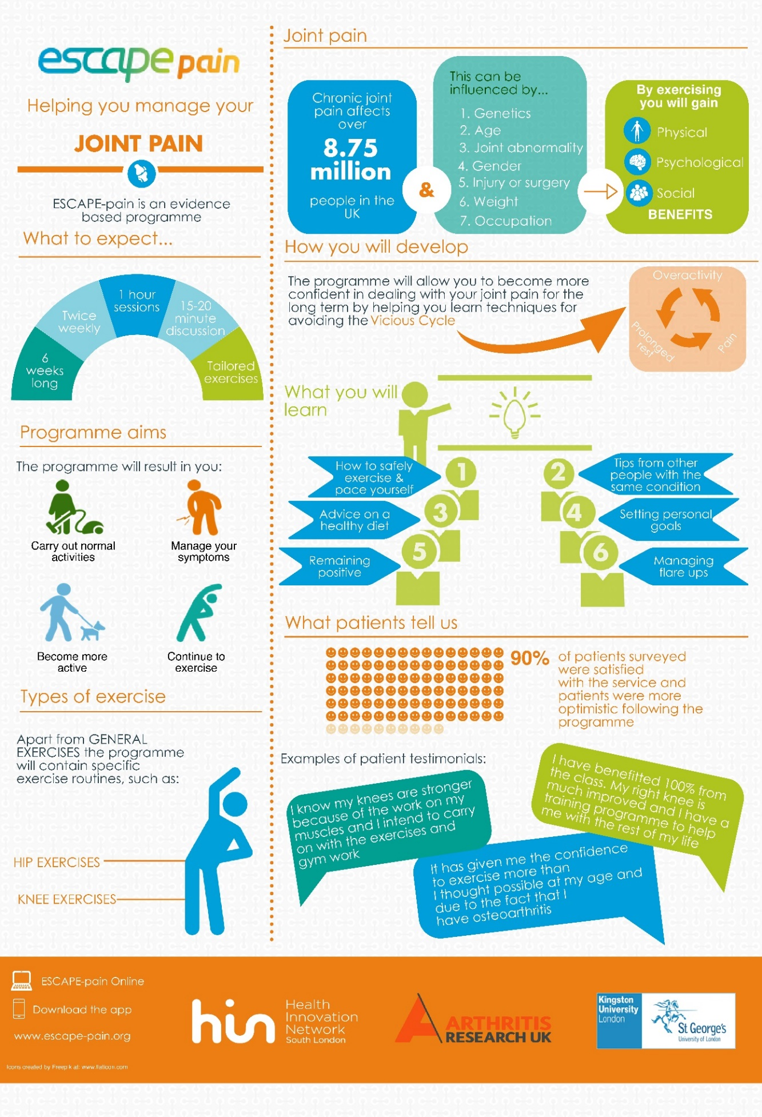

Appendix 2: Provider infographic
